**Capstone Project**

**Fall 2022**

**Store Aggregator (Grocery and Medicine)**



Project Supervisor - Professor Mamoun Samaha

**Developed by:**

**Sonal Pande - 39835191**

**Savita Khadse - 27565948**

**Luman Yang - 46627097**

**Kyiv Edwards- 14778130**

Table of Content

1. Goal
2. Objectives
3. Mission
4. Management Team
5. Overview

5.1 Why Store Aggregation

5.2 Operational Logic

5.3 Service Differentiation

5.4 Roadmap

1. Strategy

6.1 Porter’s 5 Forces

6.2 SWOT Analysis

6.3 VRIN Test

6.4 Balance Score Card

6.5 PESTEL Analysis

7. Our Offering

8. Value Proposition

9. COVID-19: A Catalyst for Market Expansion

10. Competitive Analysis

11. Our Differentiation Strategy

12. Our Ideal Customer

13. Optimization Strategy

14. Industry overview

15. Target Market Research

16.Target Customer Marketing

17.Our Revenue Source

18.Our Cost

19. Financial Objectives.

20. Main project file details

21. Website development using django

21.1 Technological stack

21.2 Use case diagram

21.3 Database and table creation

21.4 Entity Relationship diagram

21.5 Modules and file details

22. Technological advantages

22.1 Introduction

22.2 Architecture

22.3 Features

22.4 Advantages

**Goal**

The goal is to enable an online grocery delivery platform (app) for customers from their trusted shops within a short span of time by acting like an aggregator for regional grocery stores.

**Objective**

Just like Expedia is the largest platform to book air tickets without owning any aircrafts, similarly, we want to be the largest grocery selling platform without having any store in place or any grocery as inventory.

**Mission**

Our mission is to be an online aggregator for Stores like grocery stores and medical stores and provide online delivery to customers from these nearby stores.

**Management Team**

Sonal Pande - Planning, Strategy and Operations

Kyiv Edwards - Optimization

Luman Yang - Marketing Research & Financial Analysis

Savita Khadse - Website /App

**Overview**

This is how the overall system works. As soon as the customer downloads and open our App or website, the customer will be given an option to register themselves for free and add their address. Once they have registered, they will be redirected to the homepage. At the homepage, they will see 2 options: Grocery and Medicine. For this example, let's assume the customer selected Grocery. Under grocery, customer will find the list of grocery stores in the radius of 20 miles around them.

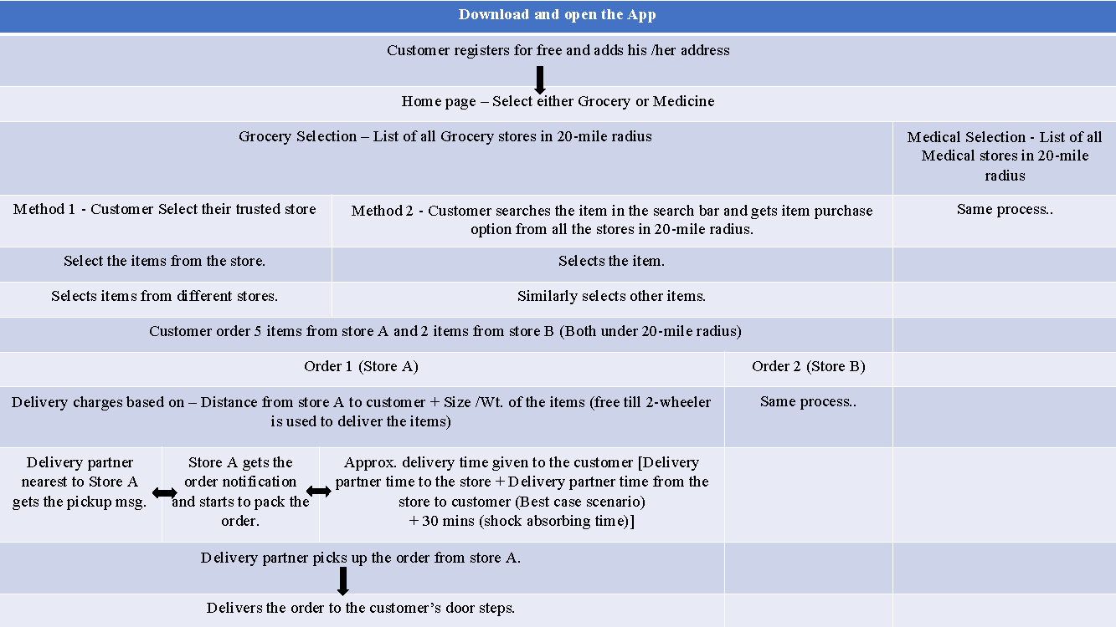

Now, customers have two ways to make their choices, the First Method is, customers can select the store from where they want to order items and then select the items from the store. then move to another store they want to order from and so on.

The second method is, customers will also see a search bar at the top of the grocery store list. They can go there; type the item they want to buy and this will give them a list of that item at different stores with the pricing and type. They can then make their choice and select the next item in the same way.

Once all the items are selected and added to the cart, from any of the 2 ways, the customer will see their order and the delivery charges applicable. The no of orders will be = the number of stores from where the items are required. And the delivery charges are based on the distance of the stores from the customer location.

In this example, let’s assume customer ordered 7 items, from which five items are from store A and two items are store from store B. So, that would mean, 2 orders will be created, and the delivery charges will be = Distance of store A to customer location + Distance of store B to the customer location + extra charges if 4 wheeler is used to deliver any bulk items. For items that can be delivered by 2-wheeler, the extra charges will not be applicable.

Then In the next step, 3 things are happening simultaneously.

First - Delivery partner nearest to Store A gets the pickup msg.

Second - Store A will get the order notification and they will start to pack the order.

Third - Approx. delivery time is given to the customer. Delivery time is calculated based on, Delivery partner time to the store + Delivery partner time from the store to customer + 30 mins shock absorbing time, to absorb any delays in the order pickup or on the road etc.

After these three notifications the next steps are the delivery partner will pick up the order from the store and deliver to the customer location.

Once the customer receives the order, they will acknowledge it in the app. The acknowledgement will be received by the delivery partner and the store, they will also verify the acknowledgement and complete the 3-way handshake verification.

As a future to this, our AI based algorithm will keep on learning the pricing based on distance and the items + timing based on locations.

**Why Store Aggregation?**

We want to do store aggregation to help our society at various levels. For example, we want to help the society by helping the **elderly people** who have constant requirements of regular medicines.

We would also like to help people with **special needs** in their groceries and medicine purchase.

We also want to extend our help to the **busy working professionals** with whom most of us could relate. We want to give them some time back by taking care of their daily grocery requirements.

We would also love to help the **mothers** specially with younger kids who require more time for the kids and the household.

Other than this, we would also like to serve the society in difficult situations like in the case of a **pandemic**. We have recently experienced one, so we know how important role our service can play in such testing times.

Last but not the least, we would also like to help people who have **passion for life**, this is a very interesting category, by this category we mean to address the people who want to make max out of their time by indulging in some hobbies or just by spending more time with their family.

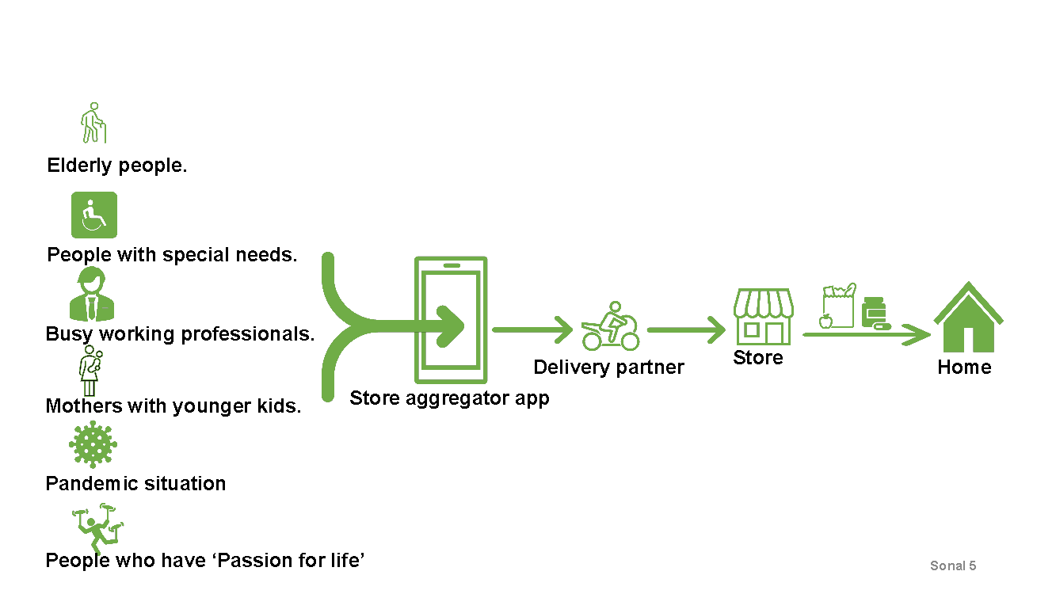

**Operational Logic**

How are we applying operational logic to calculate the delivery charges and the ETA. The delivery charges charged to the customer is our major source of revenue until we establish ourselves and start the subscription-based model.

The delivery charges are calculated based on the Distance of the customer from the store + extra charges if a 4-wheeler is used to deliver any bulk items. For items that can be delivered by 2-wheeler, the extra charges are not applicable.

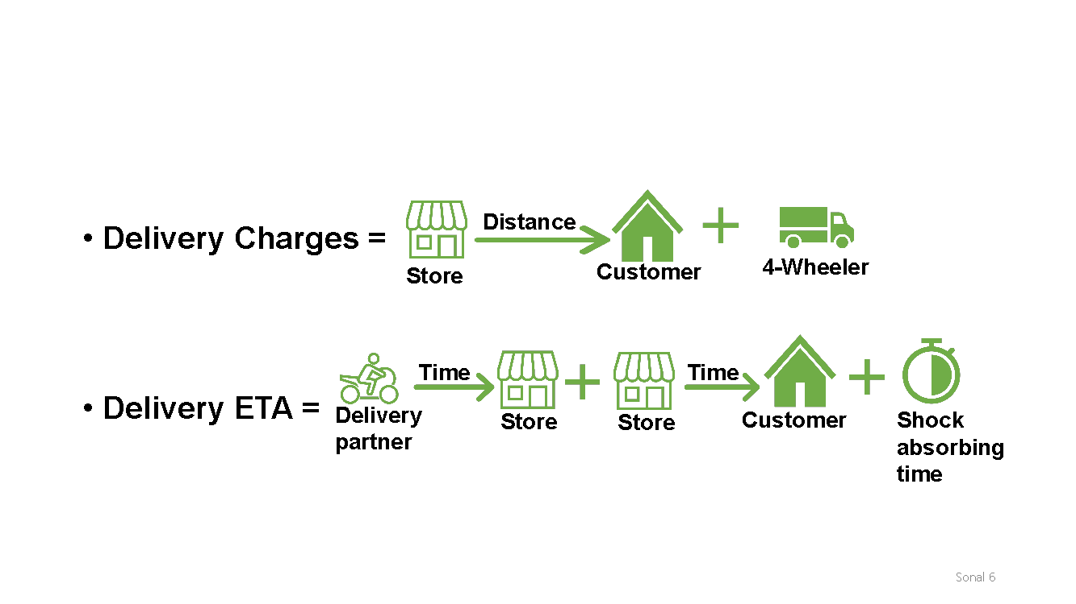

And the delivery ETA is calculated based on, Delivery partner time to the store + Delivery partner time from the store to the customer + 30 mins shock absorbing time, to absorb any delays in the order pickup or on the road etc.

**Our service Differentiation**

Based on our operational logic we can achieve our 1st differentiation of being able to do Quickest possible delivery. And our other major differentiation is, an option for the customers to choose from their trusted stores.

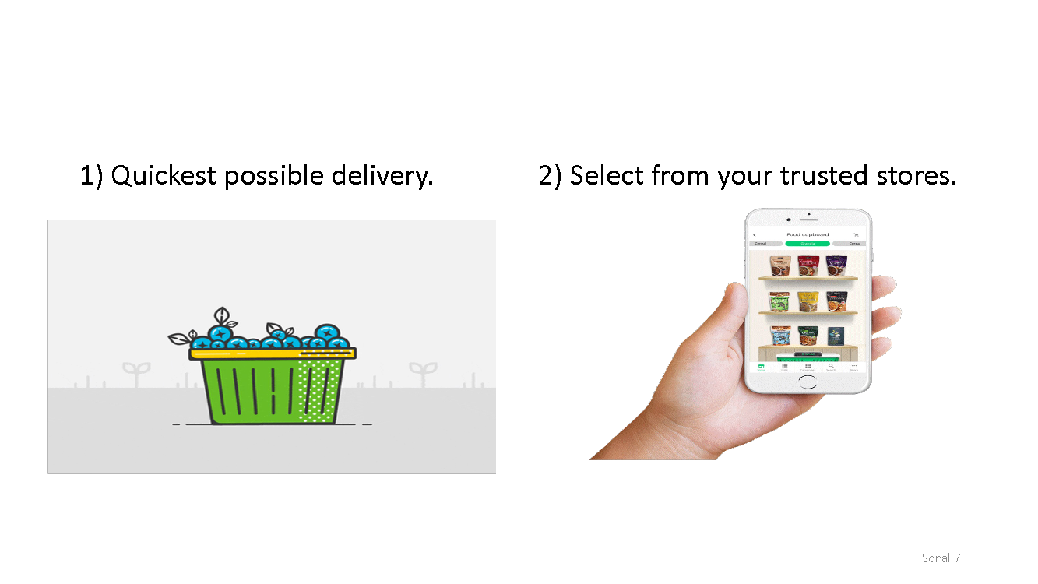

**Roadmap**

This is our project roadmap. Starting from grocery stores we would then like to move to the cold chain products which might require assets like more 4-wheelers and coolants. Then we would like to move to the next phase, which is medical store aggregation, where we could use the network effect from the grocery domain.

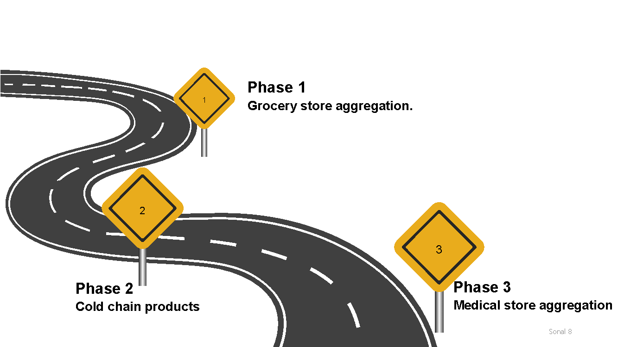

**Strategy**

Our tagline and COVID NEWS hijacking are our 2 of the major strategies for current time.

•       Tag Line - ‘**Passion for life’**Through the tagline, I would like to focus on people who have ‘Passion for life’ and thus want to make the most out of their lives. My app /service will set them free by allowing them to have a lot more time of the day than before when they needed to spend hours every week on grocery shopping.

•       Covid 19 ‘**Newsjacking’**   
The Covid 19 Newsjacking is a very effective strategy for marketing right now. As the offered service directly influences the % of public interaction, it can help in controlling the pandemic spread to a great extent. It can help people avoid the necessary but unwanted visits (due to the virus spreading fear) to daily need grocery stores and medical stores. Therefore, this strategy will not only help the business but also the government to control the pandemic and safeguard the people.

Apart from that we have used various strategy frameworks to work on our strategy, like Porter’s 5 forces, SWOT Analysis, VRIN Test, Balance Score card and PESTEL Analysis. Let us have a look on the details below:

**1)    Porter’s Five Forces**

Starting with Porter's five forces, this chart was made by me in the Excel sheet and then I took screenshots to add them here. According to this chart, our project strategies should focus on the threat of substitutes and the threat of new entrants as they cover the max length and because the top right part of the chart is heavier.

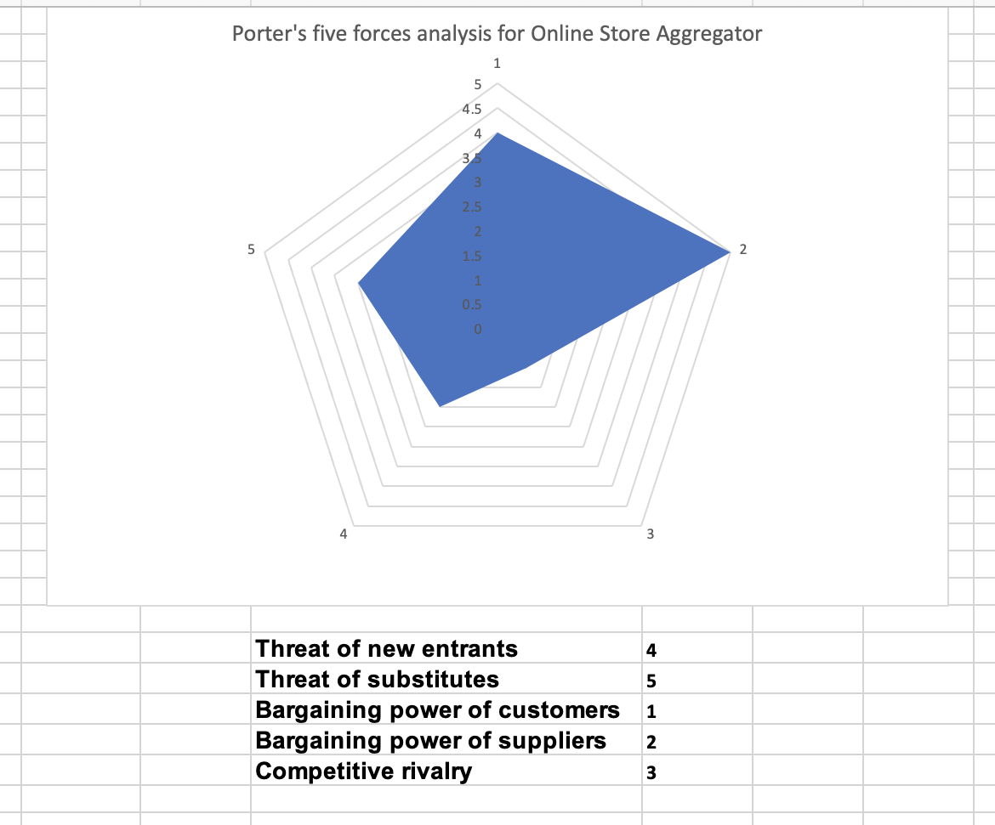

**2)    SWOT Analysis**

Next is one of the very important analyses, SWOT Analysis. There are many strengths, weaknesses, opportunities, and threats in our service line. Some of the important ones are;

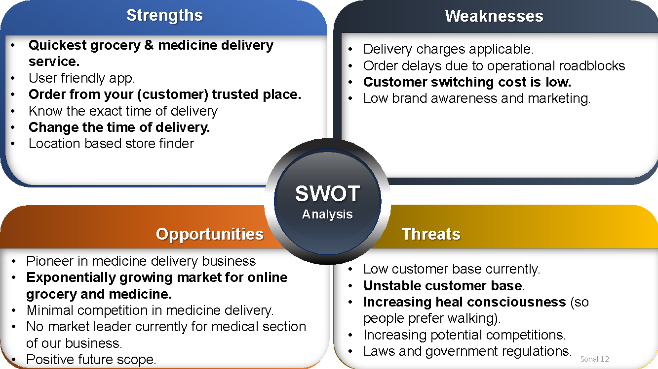

Two of our most important strengths are derived from our service differentiation. Quickest possible delivery and option for customers to choose from their trusted stores. Apart from this there is 1 more feature which is a great strength for us, the feature is that the customer can change or specify a delivery time of the order if required according to their requirement.

**One** of the major weaknesses is that the customer switching cost is very low. At Least until we establish ourselves well to start the subscription-based model.

**In** opportunities we have plenty, however the major one is the exponential demand and growing market for online grocery and medicine.

**Finally**, the 2 major threats in our SWOT analysis are, unstable customer base, due to mainly the low switching cost again. And the 2nd threat is interesting and very important, it is the heal consciousness of people, meaning, these days people are very health conscious, and many of them prefer to walk and pick up daily grocery stuff on their way on foot.

**3)    VRIN Test**

For the VRIN Test, we think the maximum weightage should be given to the delivery time and the quality of service as they are the most important factors for the customers in our project line. And our final VRIN score has come out to be 87 according to our analysis.

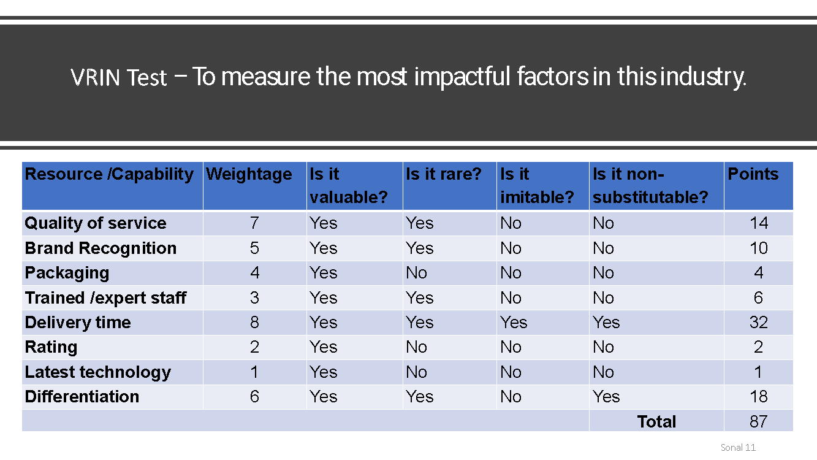

**4)    Balance Score Card**

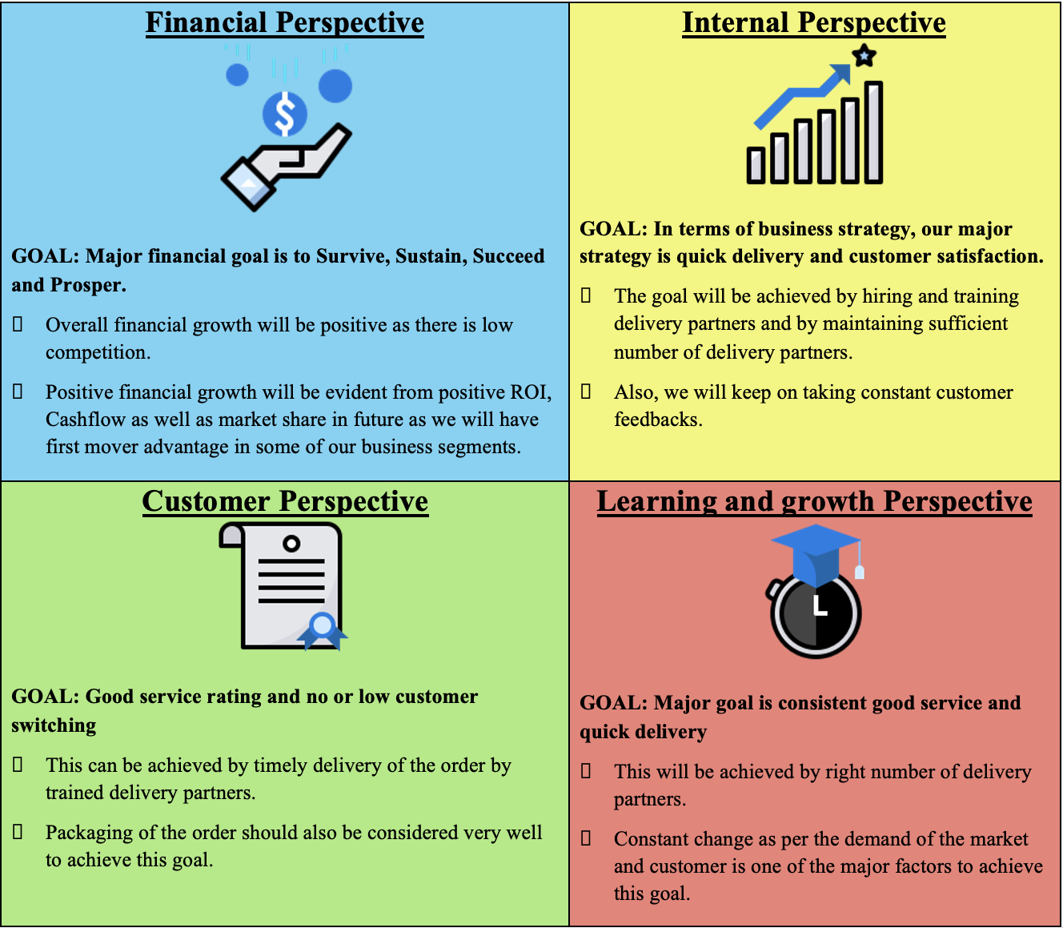

**5)    PESTEL Analysis**



**Our Offering**

Store Aggregator is an online and in-app aggregator for grocery stores, retail stores, and pharmacies. Consumers will utilize our platform as an “errand runner”, meaning that they will place pick-up orders at their favorite stores and utilize our application to have their orders delivered in a timely fashion.

**Value Proposition**

Our Store Aggregator allows consumers to have multiple pick-up orders delivered from different stores. We have taken the substantial cost and hassle away from tracking orders on multiple different platforms. Customers no longer have to be overwhelmed by multiple calls from drivers, incorrect time estimates, and multiple delivery, service, and environmental fees. This service is perfect for busy families, disabled persons, and elderly individuals, as well as event planners, business owners, and anyone looking for an extra runner.

**Objective:**

The goal is to enable an online grocery delivery platform (app) for customers from their trusted shops within a short span of time by acting like an aggregator for regional grocery stores.

In terms of cash, this business model will charge delivery charges based on product weight and delivery distance. Additionally, there will be a 2-3% convenience fee charged to stores for increasing the customer base.

# 

# **COVID-19: A Catalyst for Market Expansion**

# The universal push towards greater convenience steadily grew the online grocery delivery industry for many years. The unexpected onset of the COVID-19 pandemic and subsequent lockdowns led to a sudden and significant spike in demand for online grocery delivery. In an effort to remain relevant and survive, many grocery stores were forced to reposition their inventory from their shelves and onto an online platform. The overall market grew to $28.3 billion in 2020, up 52.9% from $18.5 billion in 2019 (Ibis World, 2022). During this time, many small and niche competitors entered the market hoping to offer online delivery to their local markets and to niche clientele.

**UNITED STATES GROCERY DELIVERY MARKET SIZE**

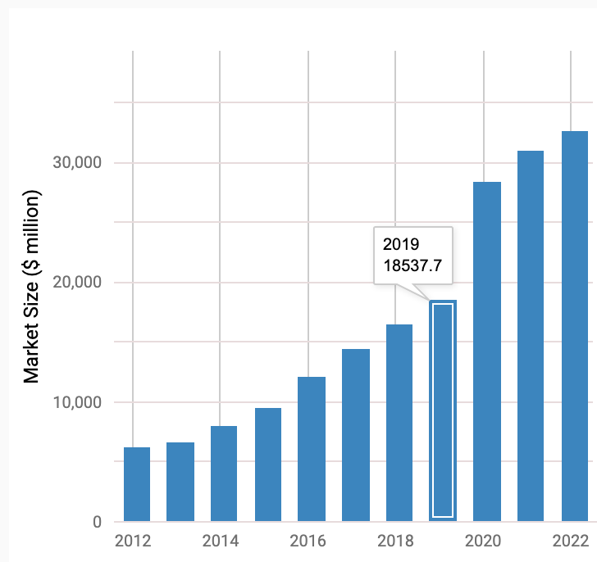

[Source: Ibis World, 2022](https://www.ibisworld.com/industry-statistics/market-size/online-grocery-sales-united-states/#:~:text=The%20market%20size%2C%20measured%20by,to%20increase%205.3%25%20in%202022.)

Although the pandemic is nearing its end, many still have not returned to grocery stores, as they have grown accustomed to the time-savings and reduced stress of choice. Going forward, the market is expected to experience a global compound annual growth rate (CAGR) of 25.3% from 2022 to 2030. (*[Grand View, 2022](https://www.grandviewresearch.com/industry-analysis/online-grocery-market) ). At this rate, it is projected that the global online grocery delivery market will reach a revenue of $2.15 trillion by 2030.

# **Competitive Analysis**

# The online grocery delivery industry is not a blue ocean. There are large players with convenient platforms and robust delivery networks. These players each utilize one of three main models.

**Online Marketplace**

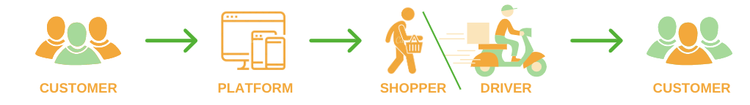

The online marketplace model is used by companies such as Instacart and Shipt. The Marketplace connects stores and consumers with independently contracted delivery persons. Consumers are able to place multiple orders but will have to pay for and communicate with numerous delivery drivers at a significantly higher price point.

**Big Box Store Delivery**

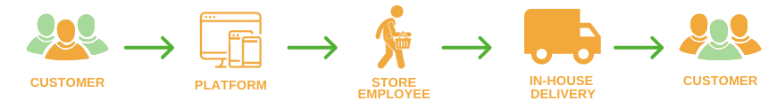

Big Box retailers like Walmart and Target have begun to utilize their in-house resources to provide same-day delivery to customers. These stores also offer in-store pickup, which can be fulfilled by our platform.

**Micro-Fulfilment Enabled Platforms**

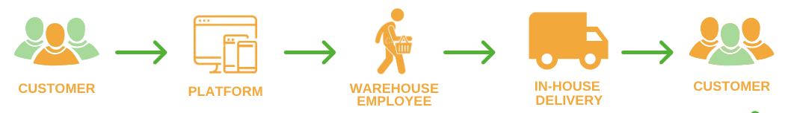

Platforms such as Amazon Fresh and GoPuff utilize a network of micro-fulfilment centers, allowing delivery times ranging from same-day to two-day delivery. These companies have their own inventory and in-house delivery network, similar to the Big Box model. They do not, however, offer in-store pickup.

Some consumers don’t mind driving to the store but prefer the convenience of having a shopper collect their items. The curb-sided/in-store pick up model has significantly grown in popularity and is a first step for many store owners looking to offer an online convenience service.

**Curb-side/ In-store pickup model**

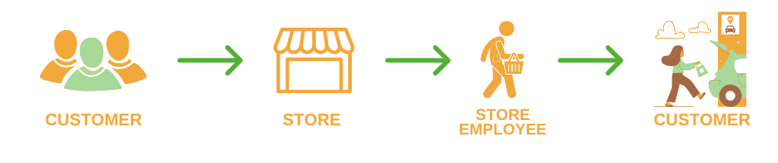

The curbside pickup model is utilized by a broad range of businesses, including grocery stores, pet stores, clothing stores, pharmacies, furniture stores, and more! Businesses have an online platform which allows customers to view their inventory, place orders, and provide payment. Customers can then efficiently collect their orders at a pre-selected pick-up time.

Our model picks up where the curb-side/in-store model leaves off. Our goal is for consumers to have a “Pick Up” option for their favorite stores.

# **Our Differentiation Strategy**

# Our business is a natural extension of the existing curb-side and in-store pickup delivery model. Our Store Aggregator provides the capability for customers to place multiple orders from stores in their local area, and have them all picked up. Our “Errand Runners” offer an additional hand for those who do not have enough hours in the day.

# 

# **Our Ideal Consumer**

Our ideal consumer is interested in saving time and money, two things which have a profound impact on quality of life. While we intend to target the elderly, disabled populations and busy families, our service can also be very helpful for young professionals and students, who have limited time, money, and often do not have vehicular transport. Business owners in need of an extra set of hands also stand to benefit greatly from utilizing our delivery aggregation services.

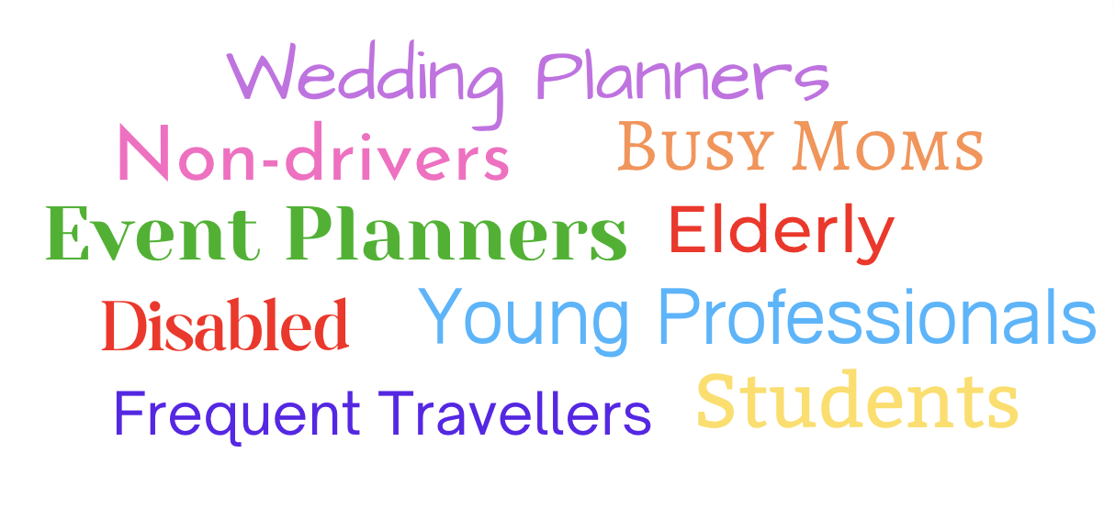

# **Optimization Strategy**

Efficiency is the most crucial aspect of any delivery business. We must ensure that we are optimizing our operations to reduce delivery times and travel distance, while upholding a high standard of quality. This will be accomplished via the following methods:

**Delivery Route Optimization**

The platform optimizes delivery routes based on pick-up times and the proximity between store locations and the customers. Navigation and real-world traffic inputs are factored into route planning to ensure reduced delivery times.

**Location-Based Pairing**

Our application matches delivery routes with drivers based on the size of their vehicles and distance from their first pickup location.

**Demand Smoothing**

Consumers will have reduced delivery fees during off-peak hours to reduce demand during rush hour.

**Order Size Optimization**

The weight and size of orders will be factored into vehicle selection. Consumers with smaller, light orders will be paired with scooter-based couriers, while heavier items will be delivered by drivers with large vehicles.

**Quality Assurance**

Quality is an important tenet of our delivery services. Errand Runners will be trained via online learning modules prior to joining our service. This program will cover road safety, customer service, cleanliness, and communication via our platform.

Excellent performance will be incentivized via the perks of our Preferred Runner Program, where they will be rewarded with merchandise and cash bonuses. Runners with poor ratings will be warned and retrained. Those who violate rules or have consistently poor performance will be removed from the platform and, if necessary, will face appropriate legal consequences.

**Industry Overview - Luman Yang**

According to statistics, the revenue of the platform-to-consumer is expected to show an annual growth rate of 8.24%, resulting in a projected market volume of US$291.1bn by 2027. And the number of users is expected to be 1517.4m users by 2027. This year the user penetration hit 24.1 % and is expected to become 32.2% by the 2027. In global comparison, most revenue will be generated in China and second is the United States.

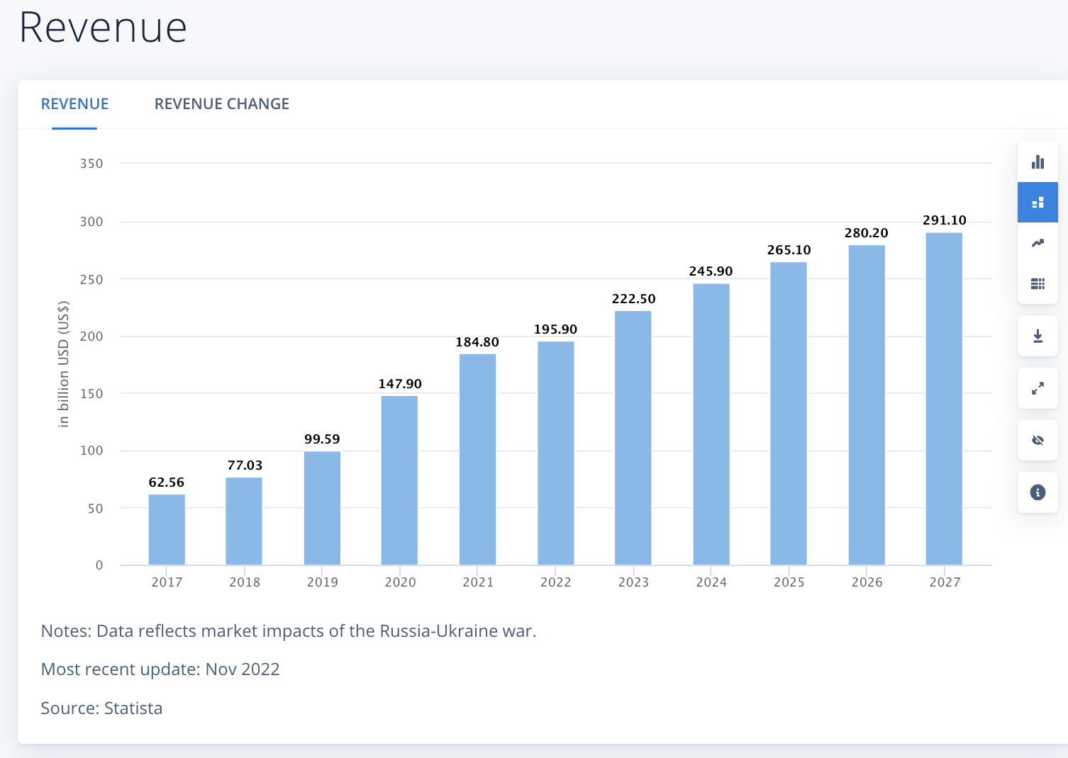

# Due to the wide expanse of UberEats, Doordash, and other apps, platform-to-customer delivery service become more and more important in people’s life. The business model has already taken share from the existing online marketplace and created a new premium market segment that will continue to drive growth in the future.

**Target Market Research - Luman Yang**

San Francisco is among the nation’s most diverse cities. Over the past three decades, the community of older adults has shifted to become predominantly a population of immigrants. Nearly 30% of San Francisco residents will be 60 or older by 2030. The number of elderly in 2020 is 23% of the population in SF.

Furthermore, one in ten San Franciscans (96,000 people) reports a disability. Almost half of the people with disabilities are under the age of 65.  These groups of people, both elderly and people with special needs face challenges in daily life including housing, income, transportation, etc.

 Another customer category we aim to served is family with children. Surprisely, there are only 16.4% of san francsico household family has children, only 17.7% of household is single mon and 5.25% is single dad. Although this customer segmentation is our third targeted group, it does not mean it is not imporant to us. As the data shown,the market we targeted is sizeable and niche which enables the business to grow in the future.

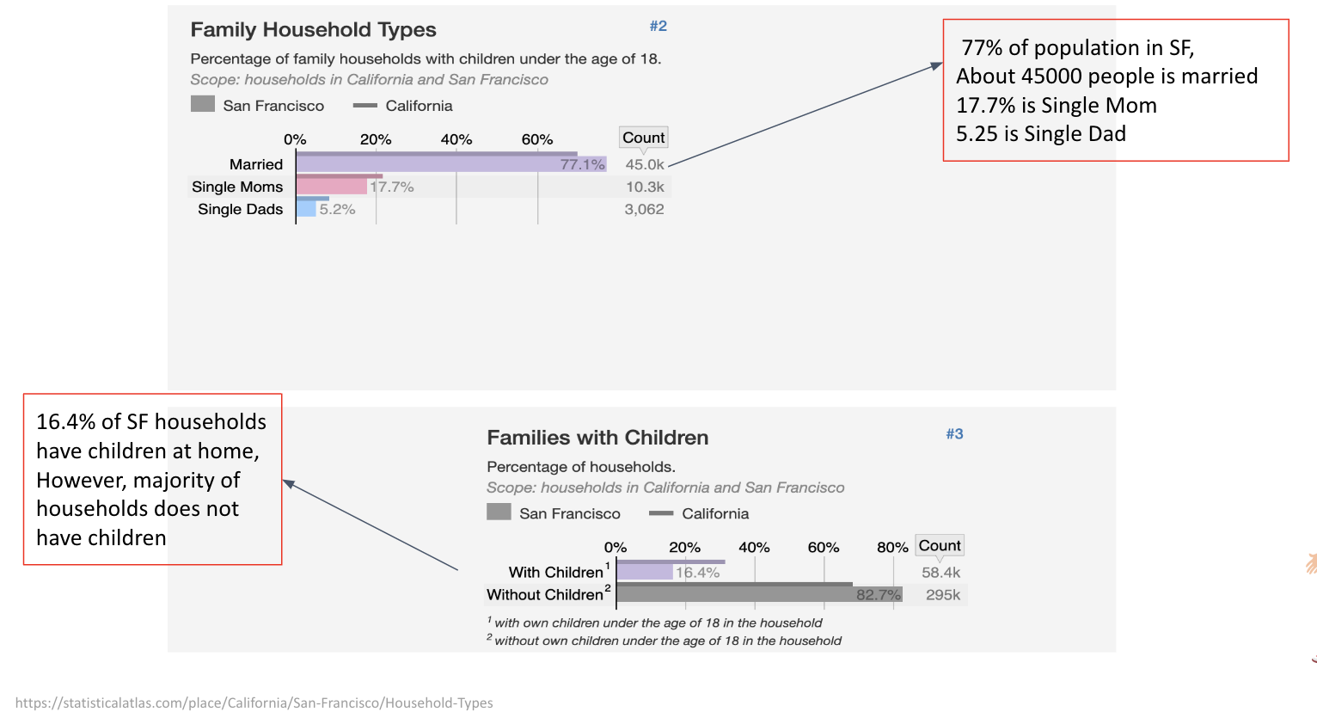

We believe that showing social responsibility and helping the elderly,people with disabilities and family with children will help us expand our brand value and market share. Any people who are interested in us can also use our services as well.

**Target Customer Marketing - Luman Yang**

Becuase the target market we face is a niche marketing, which mean we can promote our service to a small,specific and well-defiend audience. Niche marketing is often easier than promoting to a wide audience. In addition to that, we will perform our business in certain geographic areas where it helps us to reach our target audience effectively and efficiently. Since our business models is competitive and unique which enable us to meet customers’ needs, we are confident that our niche market strategy can be succesful. Our business has potential to growth and expand in the future with our undiuq selling points, once we define the best media to reach our target customers.

In the beginning of business operation, we choose to use the traditional way of communication. Our marketing campaign will be plan according to the market communication strategy list below:

1. Mail to people’s house
2. Email
3. Social Media : Facebook, Youtube,Twitter,etc
4. Word of Mouth

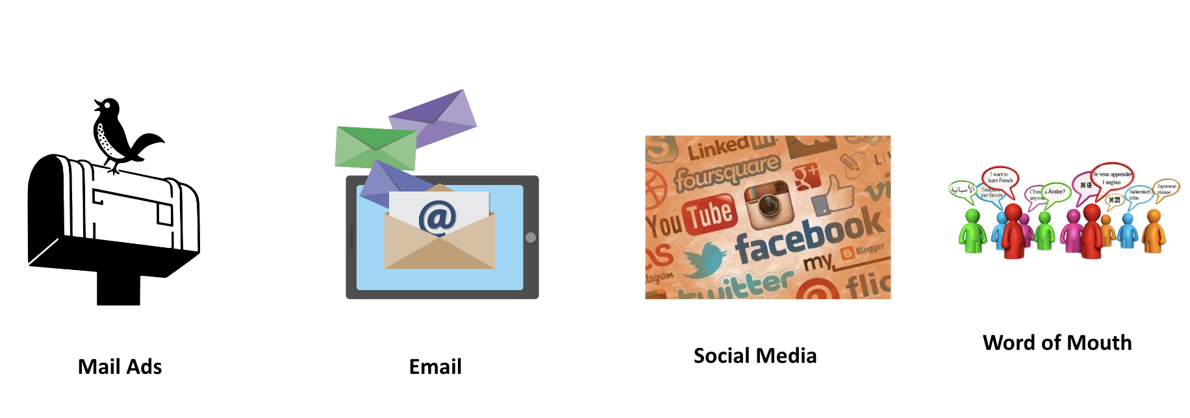

**Revenue Source -Luman Yang**

**Source1:**  Customer: Commission based - We as admin gets revenue based on transaction value/ Weight / Delivery time schedule. Delivery Fee/ Membership Subscription Cost / Service fee :

**Source 2:**  Store:  We can come up with a fixed and reasonable price and sign the contract as a partnership.  The store decides the price and items listed on the website and app.

**Source 3:** Government Funding:Because our target customer is the elderly and people with disability in the city.  There are government organizations willing to invest in activities that provide social welfare and services to this particular community.

**Source 4:** E-Retailers/wholesale Discount Bulk Deals : We can expand our product profile on our website by partnering with small business owners/ e-retailer. They can give us a Bluk item discount so that we can earn commission from the item sales on our platform.

**Cost of goods sold -Luman Yang**

We are a SaaS companies provide which is a software-enabled service, mainly delivered the products and services over the Internet. The business model has a ideal gross margin of about 80-90%. In the beginning of business operations, our overhead expense will be mainly administrative expense such as employee salayies, office equipment , rent and utility ,etc. These expense will be the fixed expense, and for the variable expenses are mianly consist of cost of good sold. We predicted that the company is able to break even within 6 month of operations.

And our main Cost of good sold include below:

* Application hosting and monitoring costs
* Marketing expense
* Software license fees
* Website development and support costs

**Financial Goal - Luman Yang**

The benefits of setting financial goals all work together to boost our business financial health. We have the short-term financial goal list below:

* Completely covered the service in the bay area.
* Revenue of $ 0.5 Million in 2023
* 20 store partnerships by end of 2023.
* Achieve 80 % of gross margins in 2024
* Provide 2x returns to shareholders in 1 years.

**Main Project file details - Savita Khadse**

**Link to open project folder and supporting files:**

<https://drive.google.com/drive/folders/1WRLNXwQTCNfVRIkjwpuBpo1LdylpMp0I?usp=share_link>

**Prerequisite:**

**Required installation before running server:**

(First download folder provided on the above link and run below installations)

>> pipenv install django - to install django in the environment

>> pipenv shell - to activate environment

>> pip3 install pymysql (change database name and root password, open mysqlworkbench)

>> pip install djangorestframework

>> pipenv install googlemaps

* include the django_google_maps app in your settings.py
* Add your Google Maps API Key in your settings.py as GOOGLE_MAPS_API_KEY

>> python manage.py makemigrations

>> python manage.py migrate

>> python manage.py runserver

**To create superuser/admin(Sample):**

Command- python manage.py createsuperuser

Username: admin

Email address: [test@gmail.com](mailto:test@gmail.com)

password:admin

**Website development using Django - Savita Khadse**

**Technological stack**

**Frontend**

Thefront-end is the HTML, CSS, and JavaScript that controls how this data looks on a webpage.

-HTML

-CSS

-Javascript **(**reference**:**<https://www.youtube.com/watch?v=lCCN_lkl3Xw&t=31s>

<https://nullphp.net/assets/posdash-html-admin-template/> )

**Serverside**

-Django-web framework

-Python -programming language to design views

**Backend**

The back-end is where the underlying database and any related logic lives

-MySQL database

**Use case Diagram - Savita Khadse**

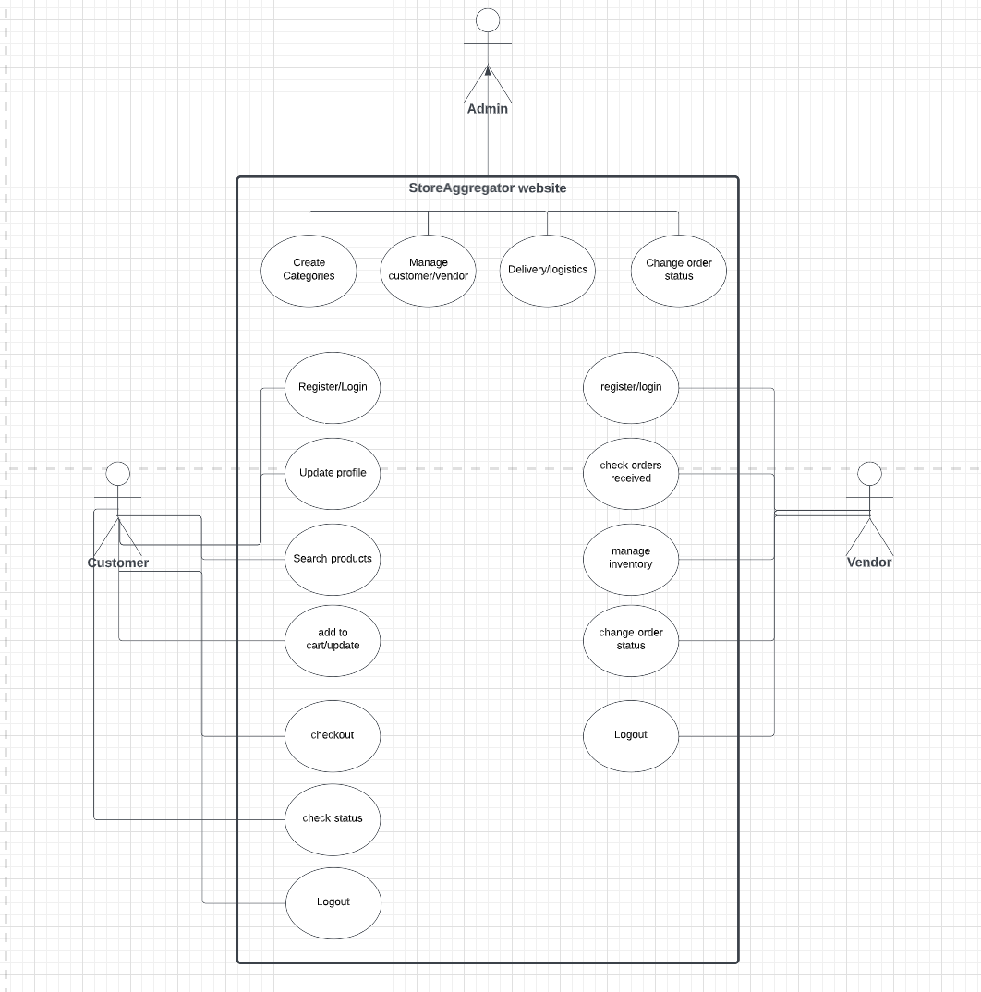

**Database and Tables creation in MySQL Workbench - Savita Khadse**

**Database name** - STOREAGGREGATOR

**Tables:**

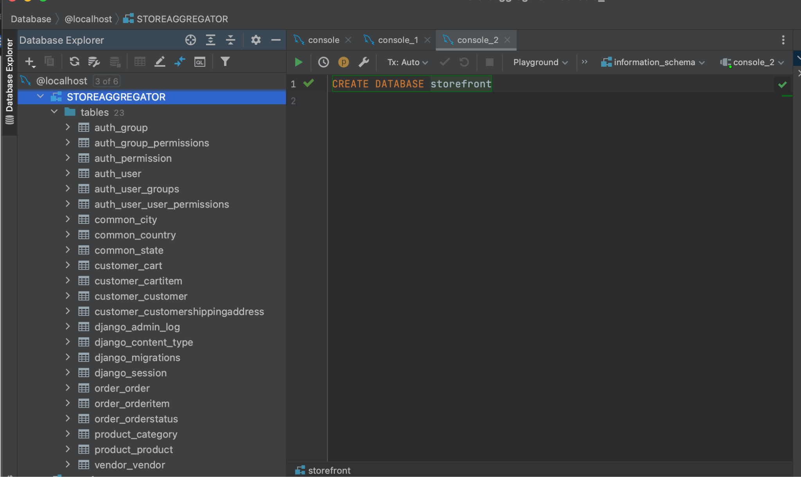

**Entity Relationship diagram - Savita Khadse**

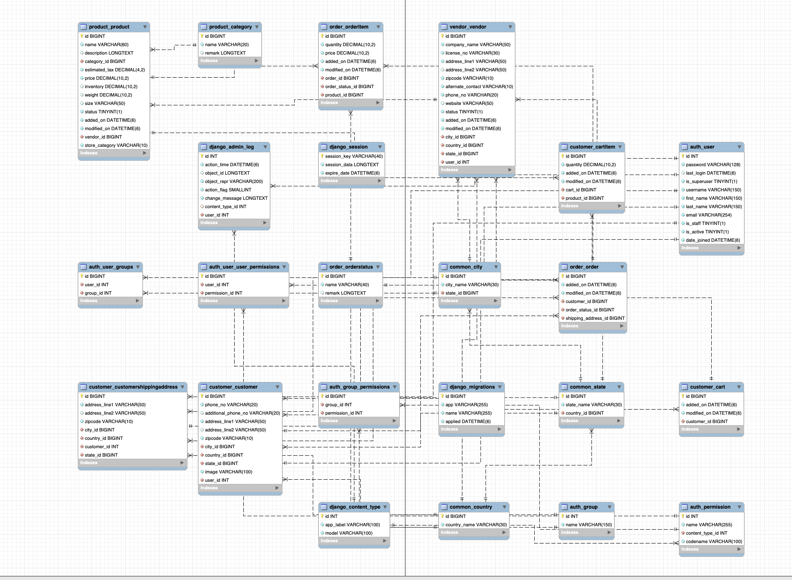

**Modules developed:**

* **Admin**: Create categories, customer, vendor, change status, notify delivery partner
* **Customer**: Register,Login, Places order, check order status, search product, update profile, logout
* **vendor**: Register,Login, checks orders, Manage inventory, add products, search products, dashboard, dispatch order, check status, logout

**Admin Login Page(**[**http://127.0.0.1:8000/admin/**](http://127.0.0.1:8000/admin/)**)**

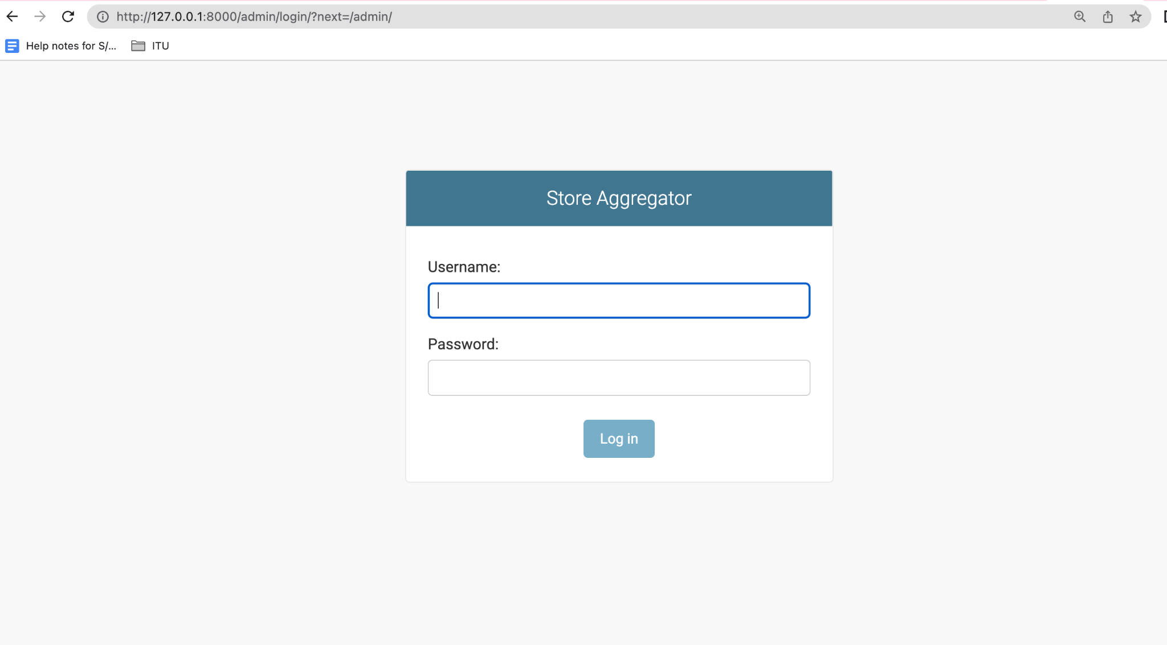

**Admin Categories page** (http://127.0.0.1:8000/admin/product/category/)

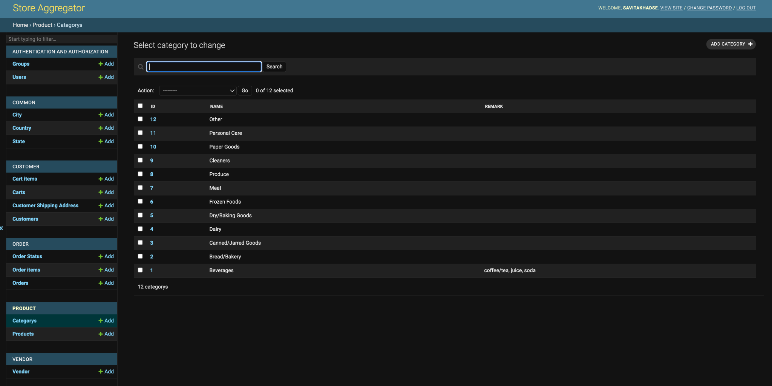

**Admin Order page (http://127.0.0.1:8000/admin/order/order/)**

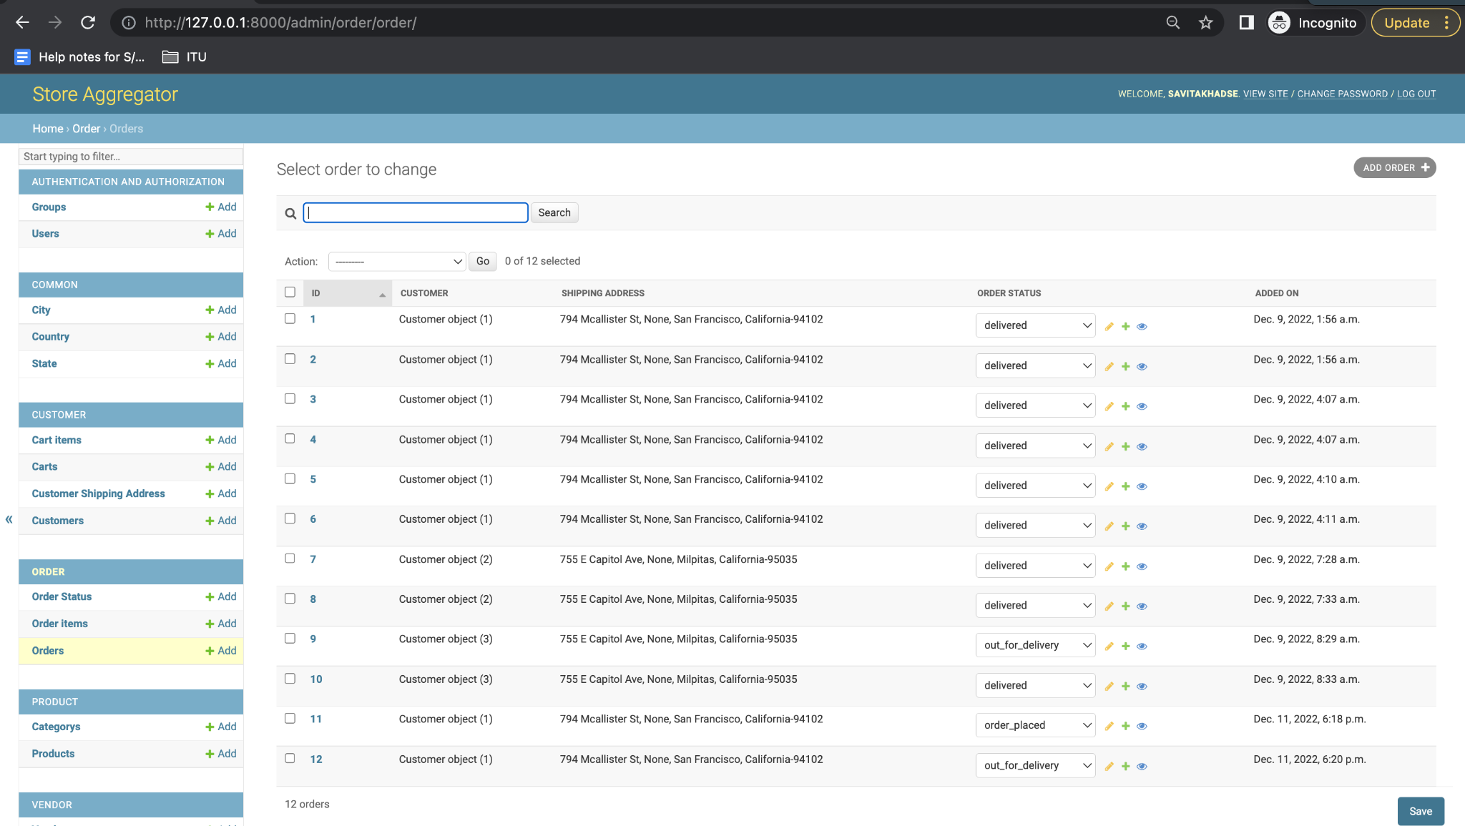

**Init file?**

It is an empty file that makes the python interpreter understand that the directory consisting of settings.py is a module or a package.

**settings.py file**

It is the main setting file of django and exists in the project's main folder. So everything inside a django project like databases, middlewares, backend engines, templating engines installed applications, static file addresses, main url configurations, allowed host and servers and security key stores in this file as a dictionary or a list. So when the django project starts it first executes the settings.py file and then loads the respective databases and engines to quickly serve the request.

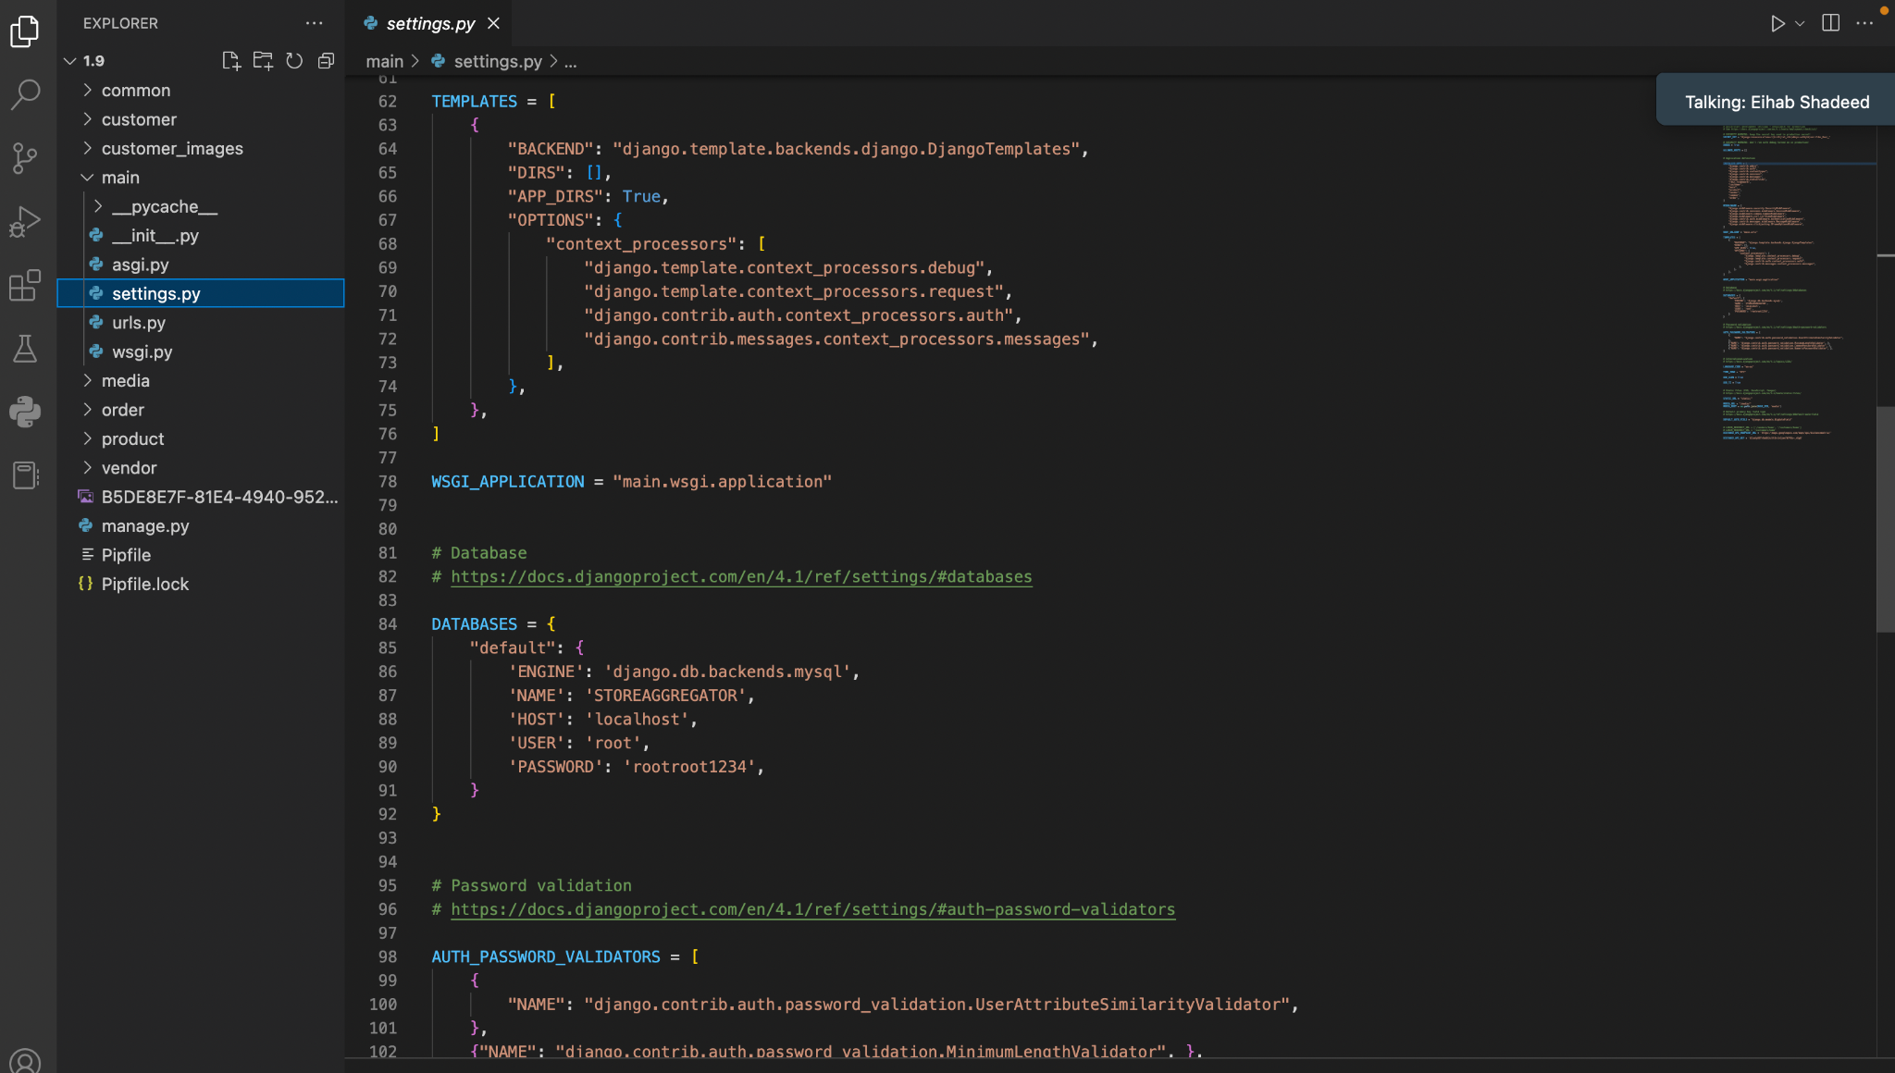

**Customer Homepage urls**

**urlpatterns = [**

**path('', views.home_before_login_view, name='home_view'),**

**path('register/', views.customer_registration, name='customer_register'),**

**path('login/', CustomerLoginView.as_view(), name='customer_login'),**

**path('logout/', views.customer_logout, name='logout'),**

**path('home/', views.customer_home, name='customer_home'),**

**path('home/categories', views.product_category, name='product_category'),**

**path('home/products', views.products, name='products'),**

**path('home/categories/<category_id>/products/', views.category_wise_products, name='category_wise_products'),**

**path('home/customer_profile_edit/', views.customer_profile_edit, name='customer_profile_edit'),**

**path('home/add_to_cart/', views.add_to_cart, name='add_to_cart'),**

**path('home/cart/product/remove/<product_id>', views.delete_from_cart, name='category_wise_products'),**

**path('home/orders/', views.customer_display_order, name='customer_display_order'),**

**path('home/orders/<order_id>', views.customer_display_order_details, name='customer_display_order_details'),**

**path('home/orders/create_order/', views.customer_create_order, name='customer_create_order'),**

**]**

**if settings.DEBUG:**

**urlpatterns += static(settings.MEDIA_URL, document_root=settings.MEDIA_ROOT)**

**customer.views.py**

Views encapsulate the logic liable to process a user’s request and return a response to the user. So either they return http response or raise an exception such as 404. Also it performs tasks like reading records from a database, generating pdf files and so on. You can import functions written in views.py file in urls.py file by using import.

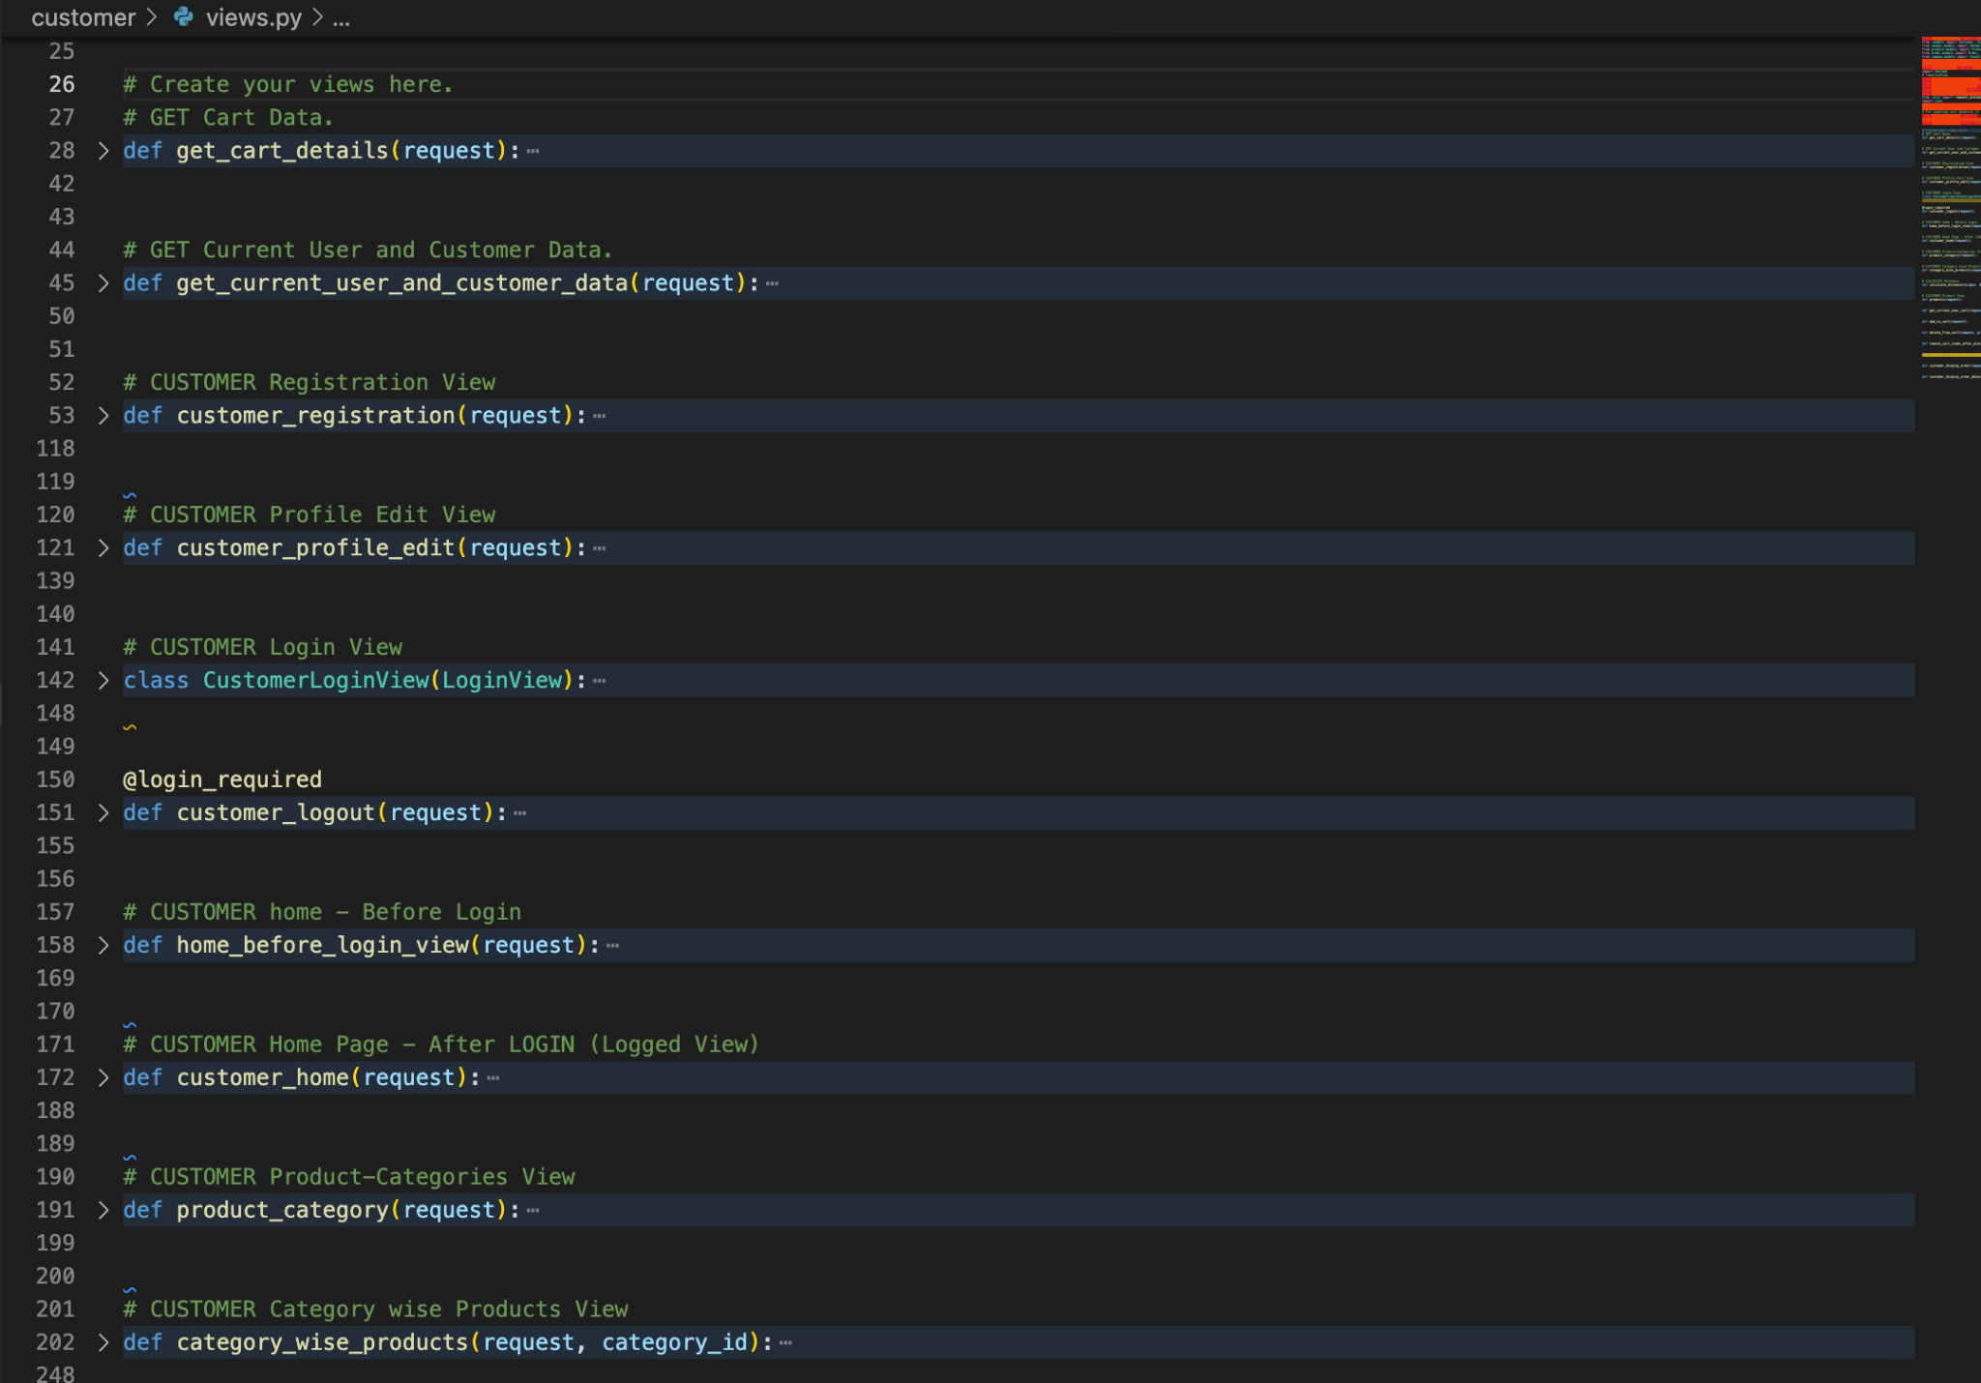

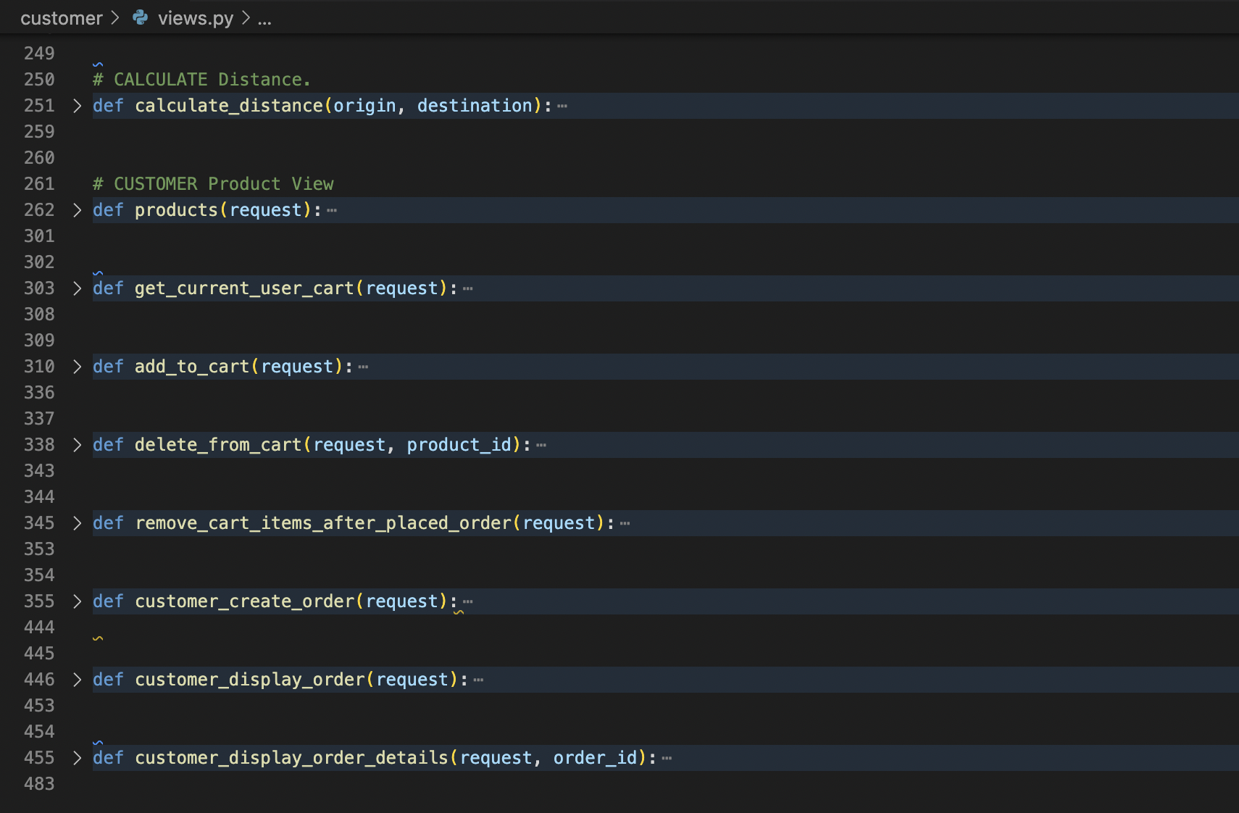

**customer.model.py**

Model.py is one of the most important concepts of the django framework. It allows us to completely define the database of our web applications allowing us to : Declare tables and fields of our database. Define all meta-data of our Database.

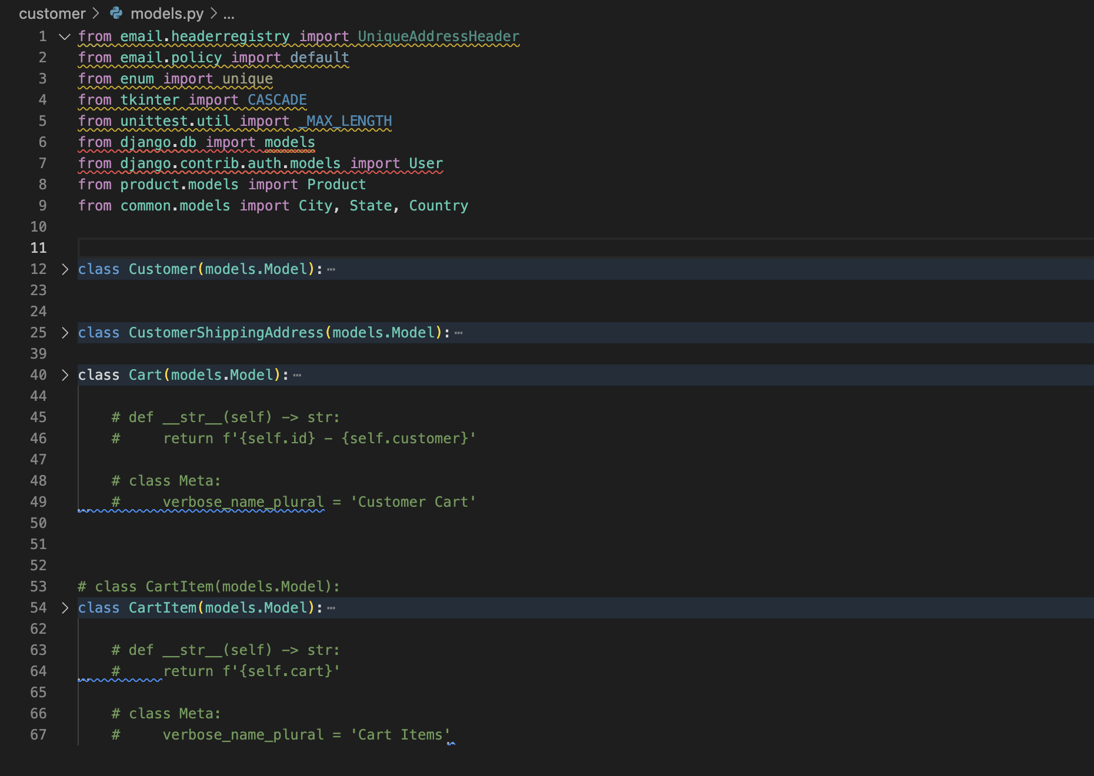

**customer.admin.py**

The admin.py file is used to display your models in the Django admin panel. You can also customize your admin panel. One of the most powerful parts of Django is the **automatic admin interface**. It reads metadata from your models to provide a quick, model-centric interface where trusted users can manage content on your site. The admin's recommended use is limited to an organization's internal management tool.

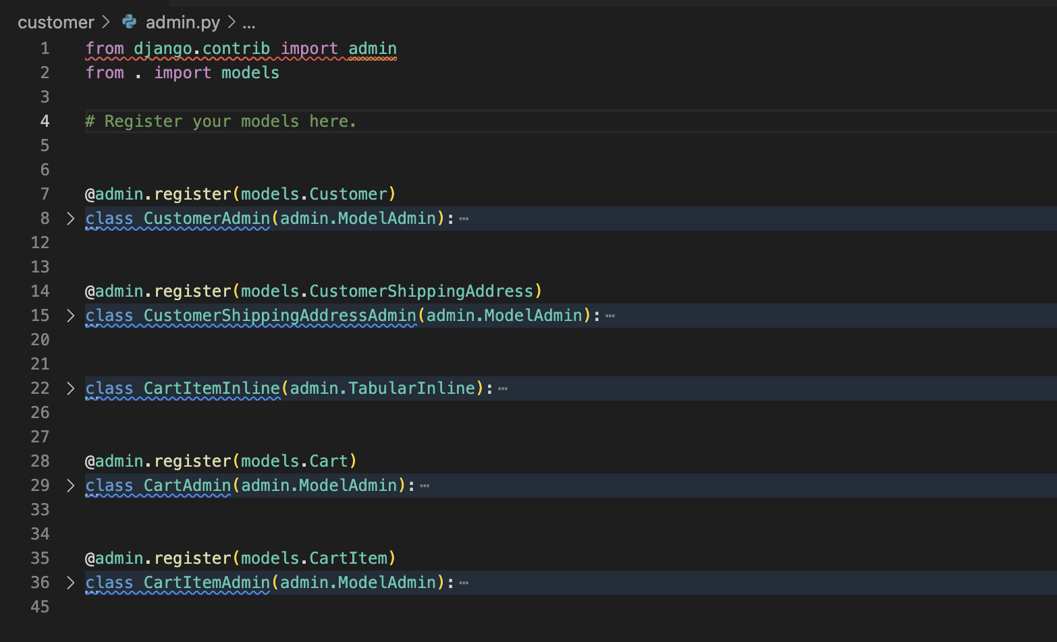

**Screenshot of customer homepage**

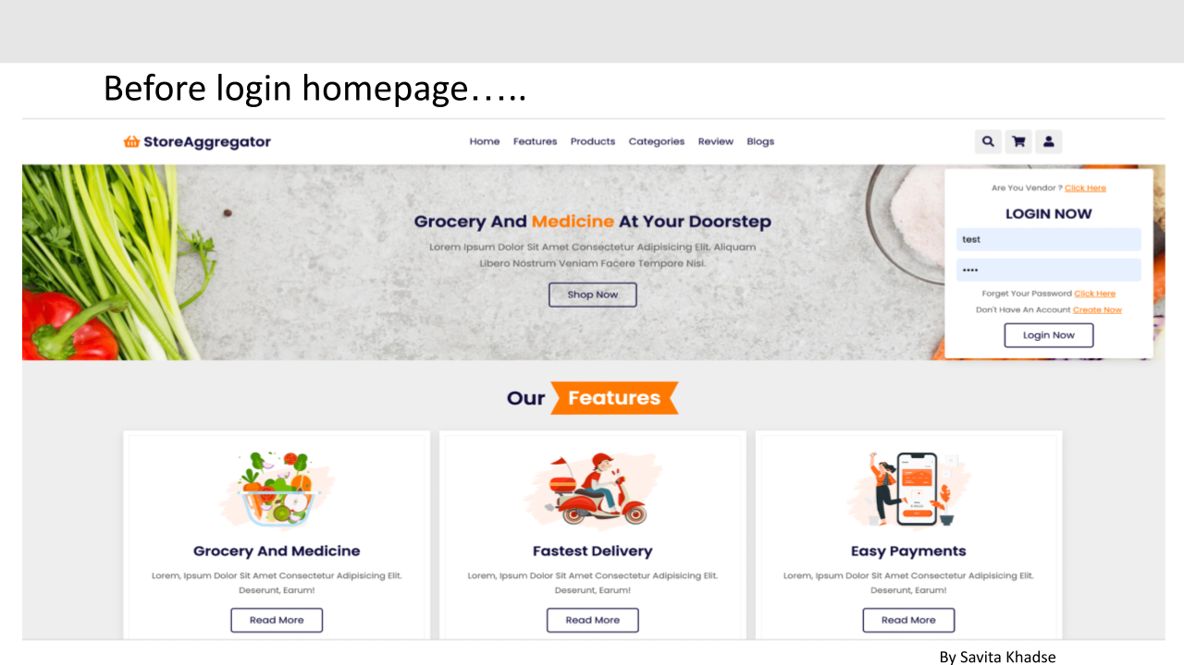

Customer update profile page

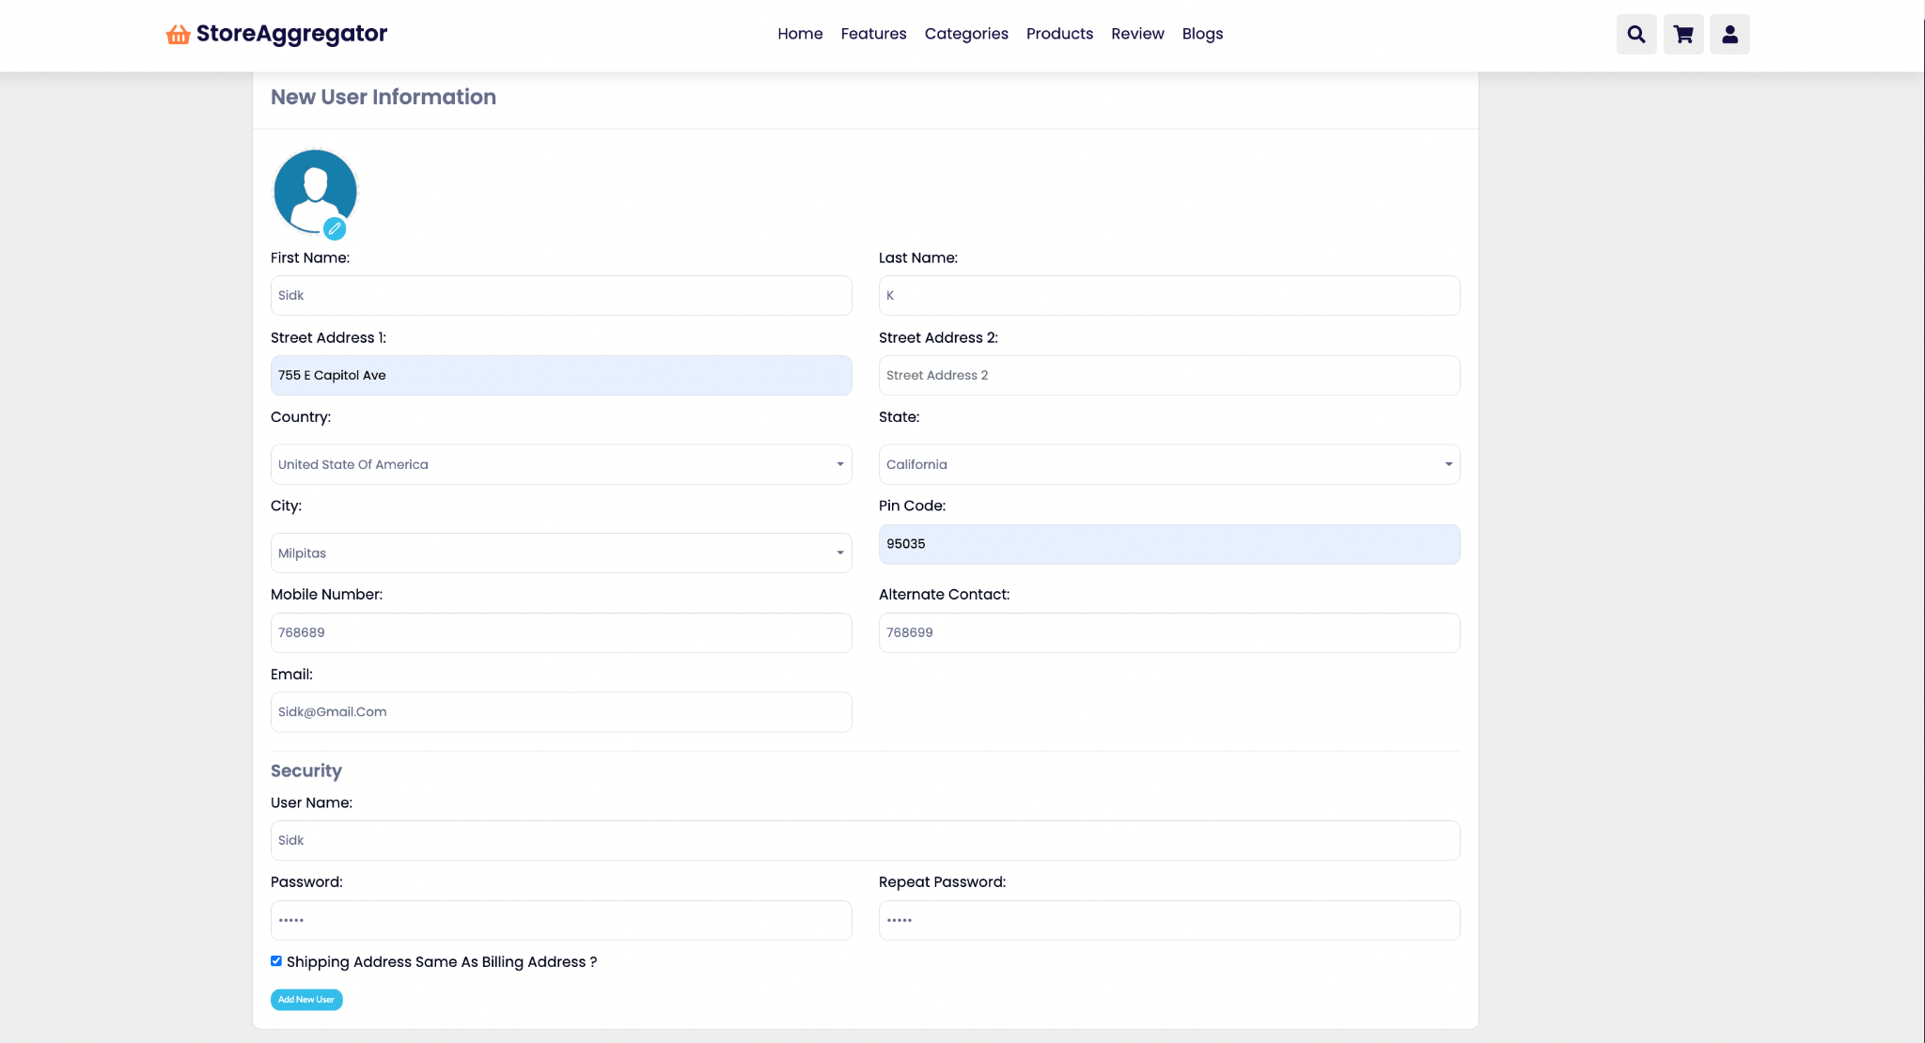

**On customer registration 4 tables records gets inserted**

Auth_user

Customer_customer

Customer_customershippingaddress

Customer_cart

**vendor.model.py**

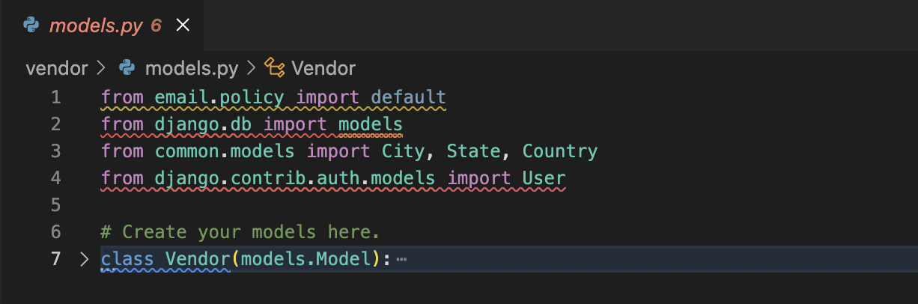

**vendor.urls.py**

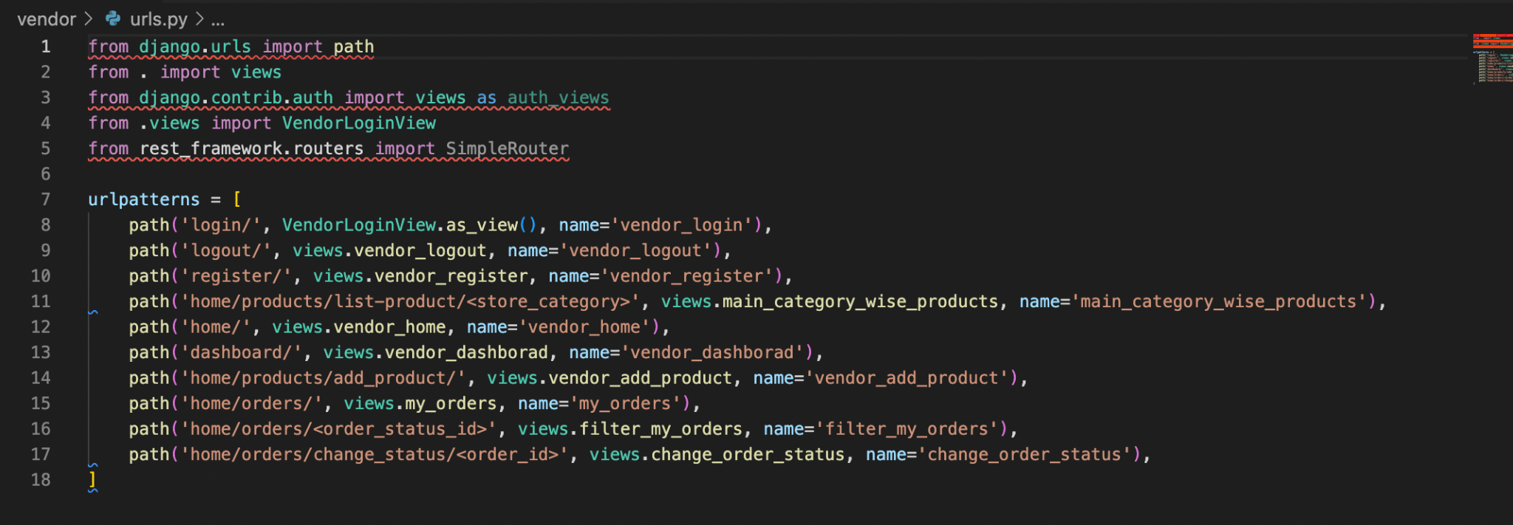

**vendor.views.py**

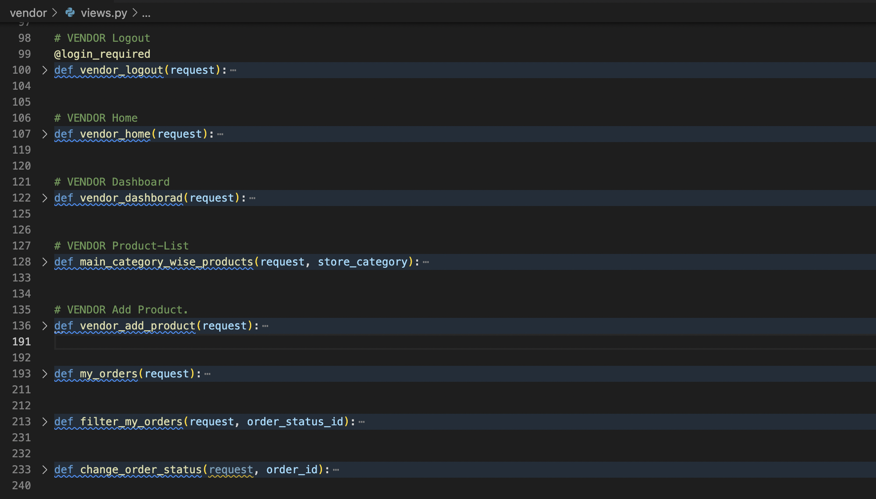

**Vendor’s Registration and login page:**

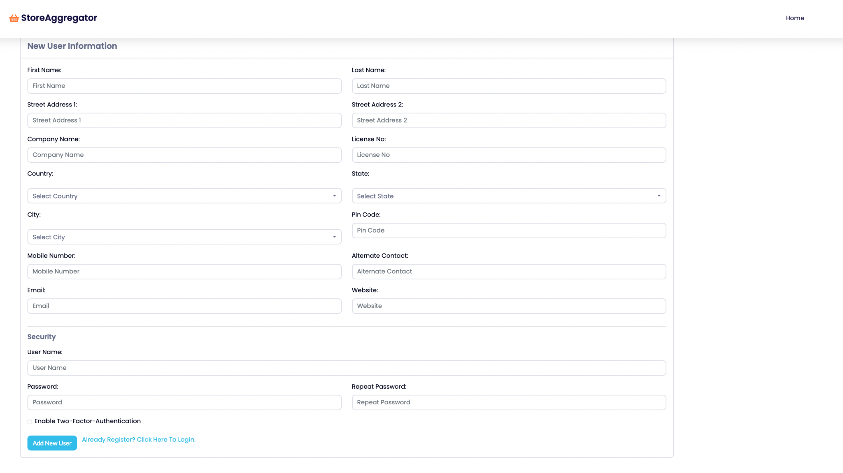

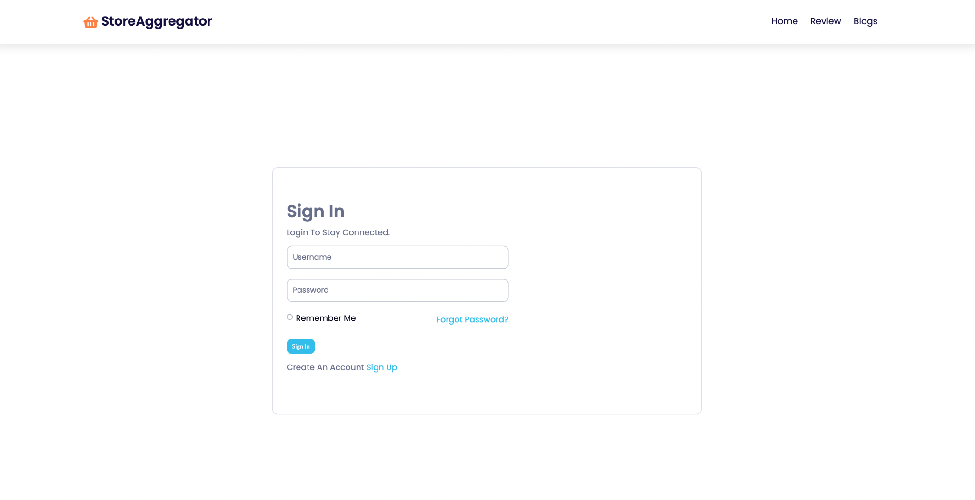

**Vendor’s before login page**

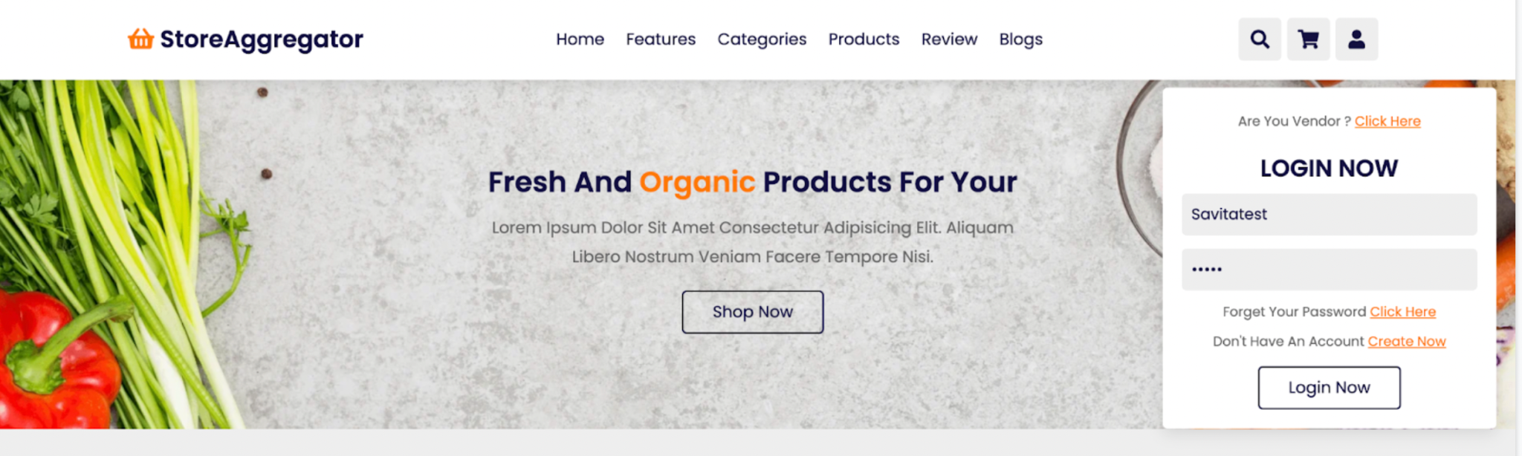

**Vendor’s before home page(http://127.0.0.1:8000/vendors/home/#categories)**

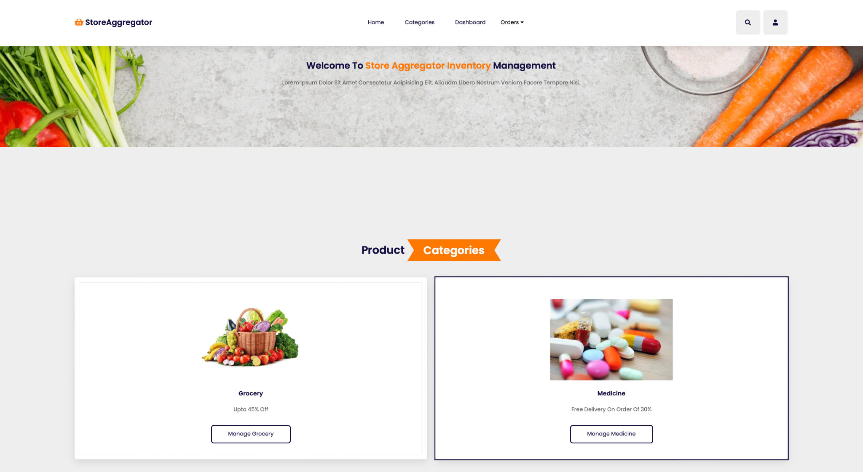

**Vendor order page(To check status of order)**

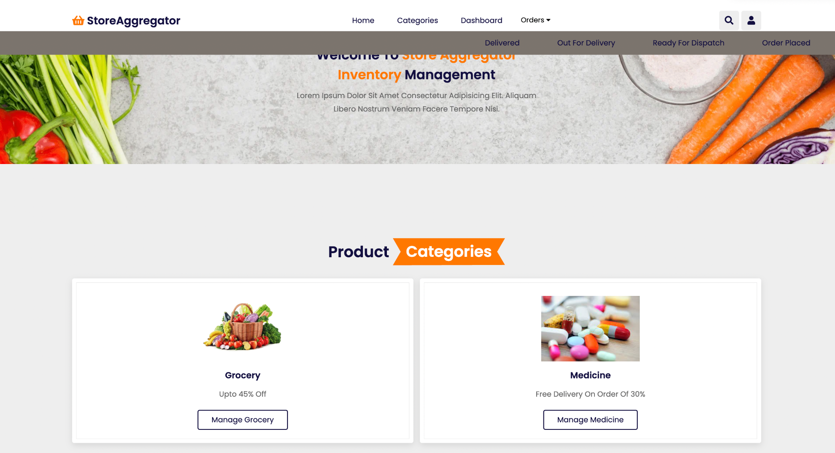

**Vendor Manage grocery page(http://127.0.0.1:8000/vendors/home/products/list-product/Grocery)**

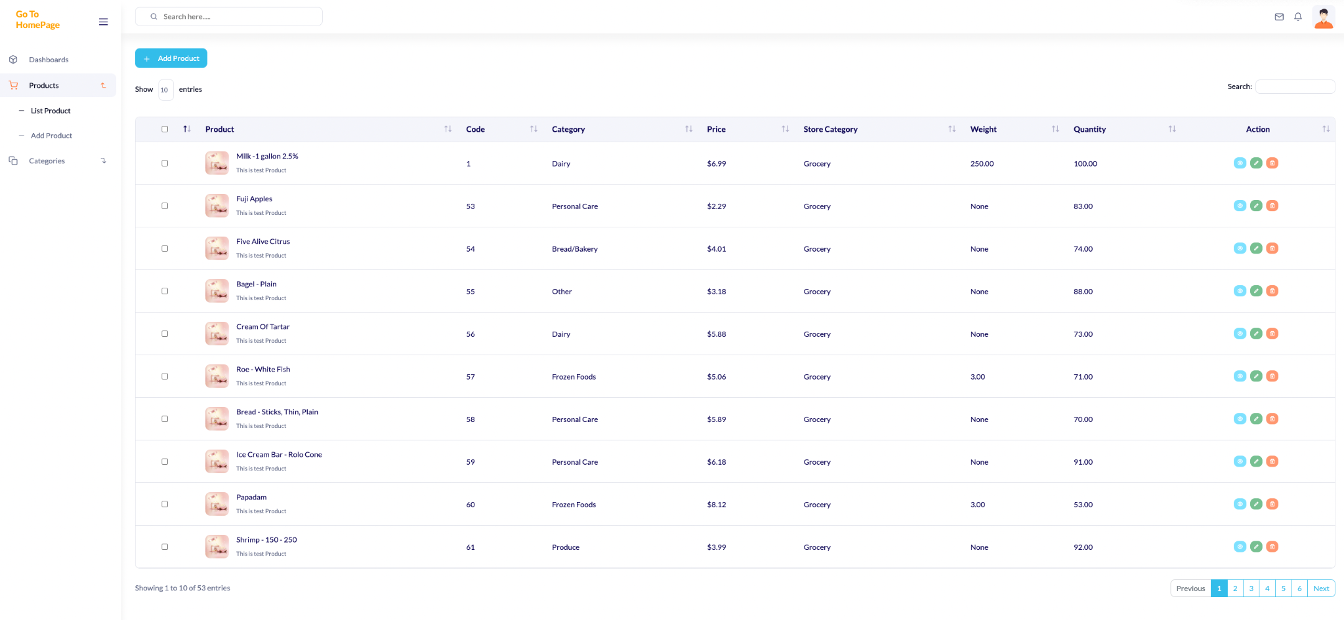

**Vendor’s dashboard (in progress to show sales profit revenues in charts for future planning)**

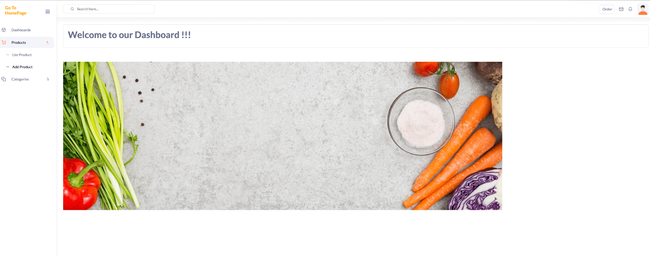

**product.admin.py**

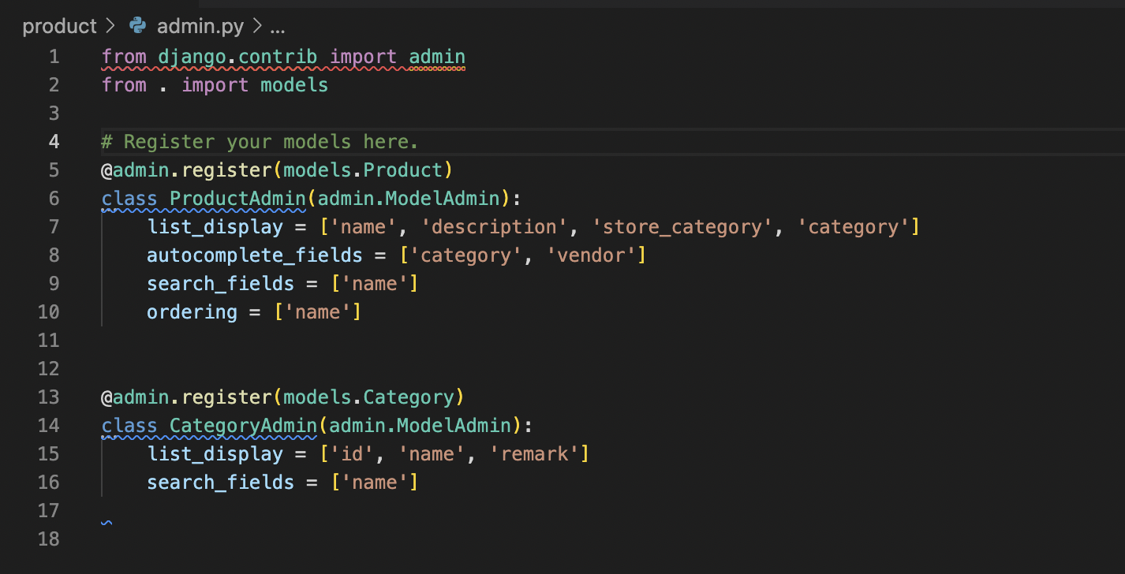

**product.model.py**

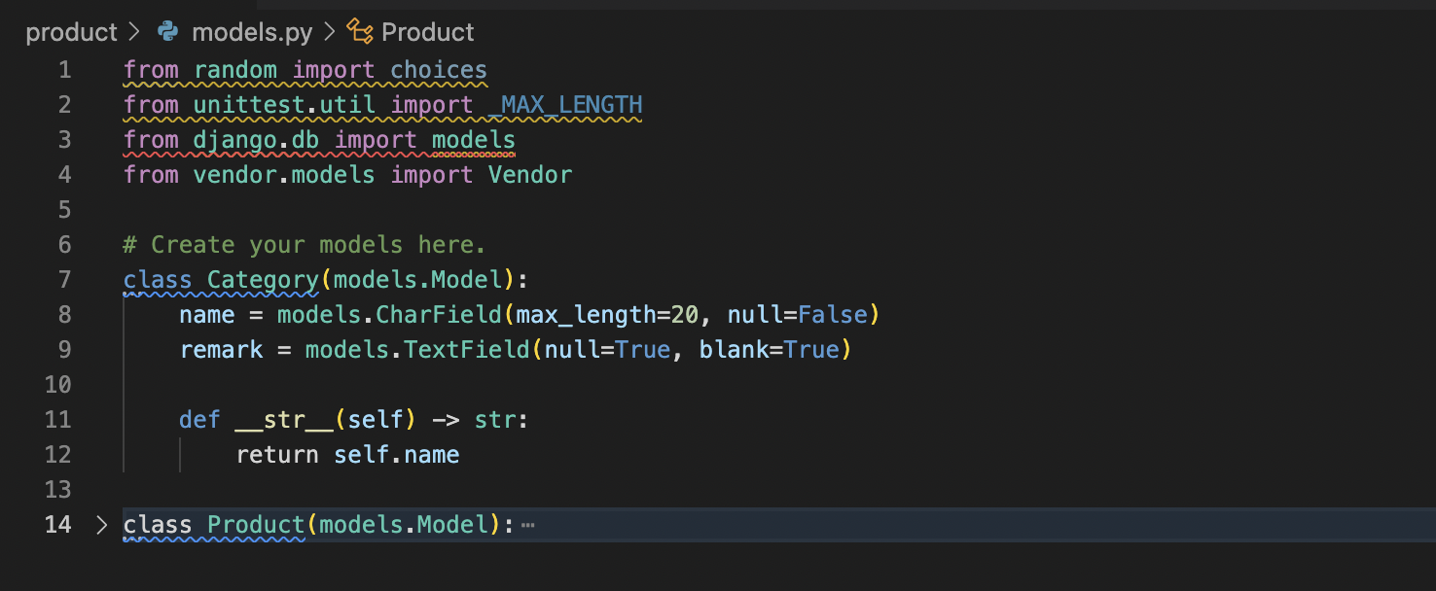

**Order.model.py**

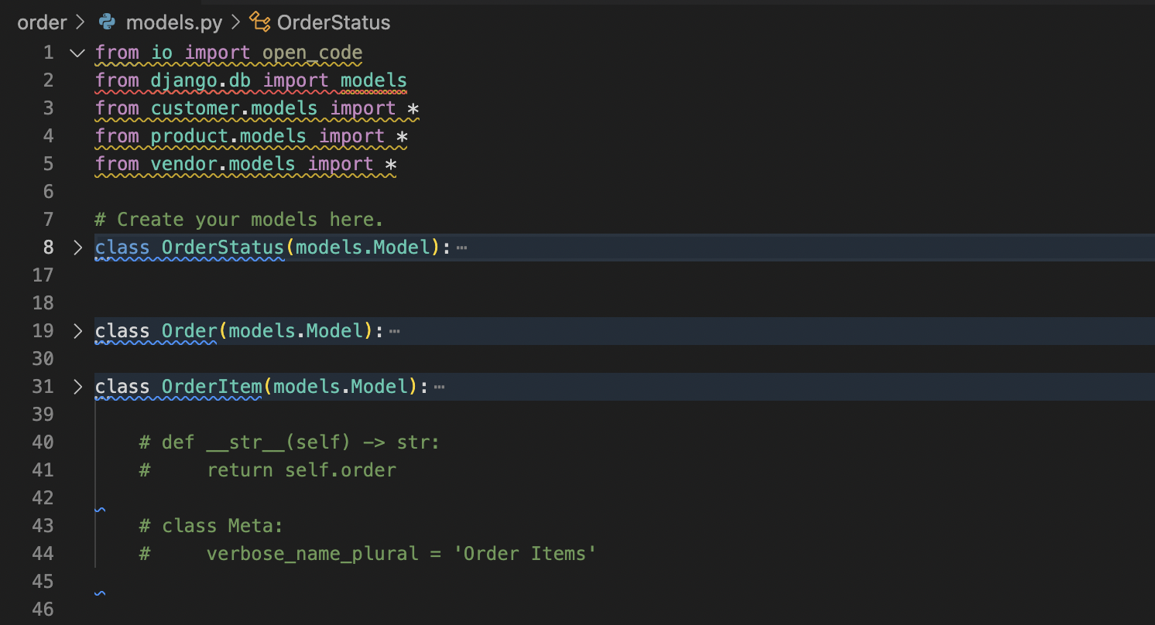

**Database and tables migrated using model.py logic**



**Technological Advantages - Savita Khadse**

**Introduction**

**Django** is an opinionated, full-stack web application framework. It is the most popular python web framework which is used for full stack app and server development. It takes care of much of the hassles of web development and allows you to focus on writing apps without any need to reinvent the wheel. It comes with many [batteries](https://docs.djangoproject.com/en/4.0/ref/contrib/) that you can use to build a fully functional web application, including static and media file management. It comes with a default admin page.

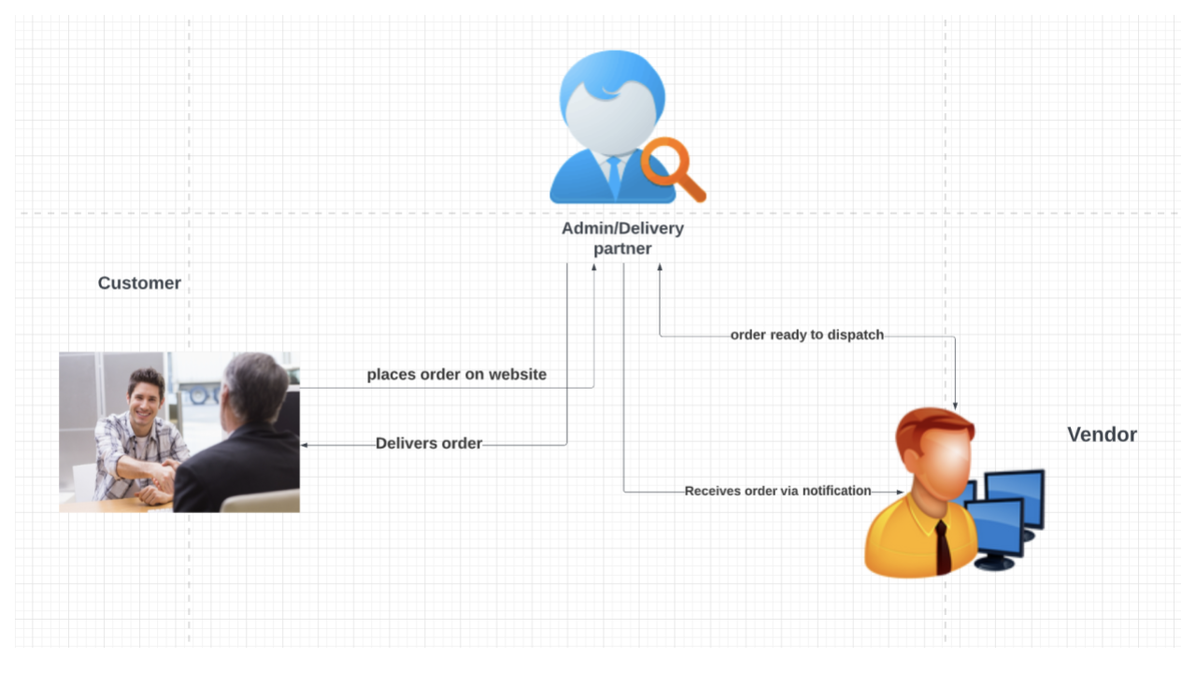

When you are logging into django based website you open the login page so it happens because the view will process the request and it sends again to the login page url and then the response is sent from a server to the browser after that you will enter the credentials in the template and the data sent back to the view to rectify the request and then the data is presented in the model. Model verifies the data provided by the user in the connected database so if the user’s data matches it sends related data such as profile name , image and so on to the views if the data doesn’t match the model passes the negative results to the views. So that’s how django MTV architecture works.

**Architecture**:

Django follows Model Template view or MTV architecture.

**Model**- Logical data structure behind the entire web application

**Template**- Presentation layer deals with presentation of the data

**View**- User interface which is what customer sees when to visit a website using url which is represented by HTML css and javascript files

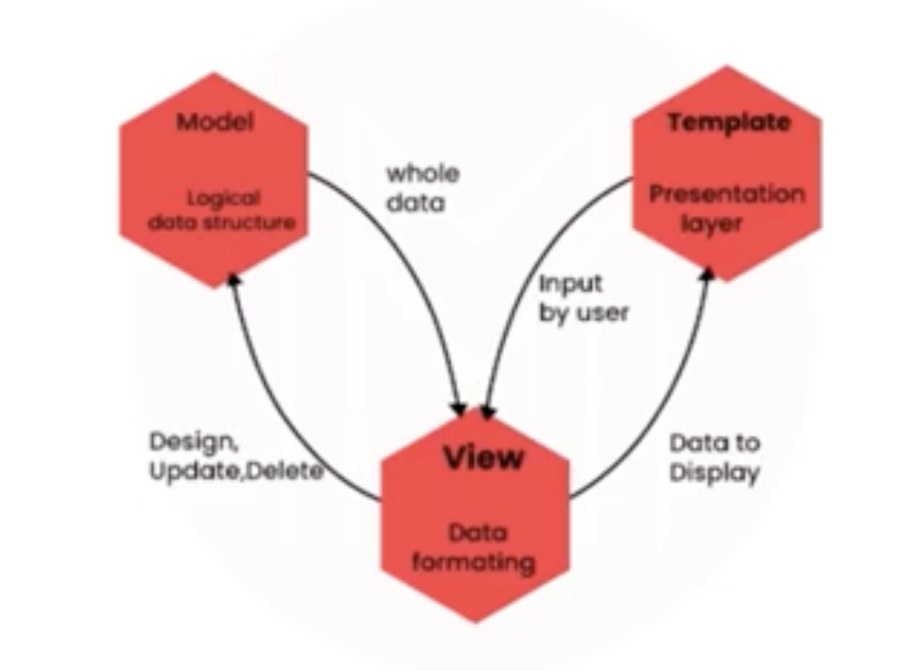

Django follows a Model View Template architecture or MTC architecture. So there are 3 components. The first part is Model. The Model is the Logical data structure behind the entire web application and signified by a database. Template deals with the presentation of the data and you also have a view. So a view is a user interface so what you see when you visit a website is called user interface and that is represented by HTML CSS and javascript files.

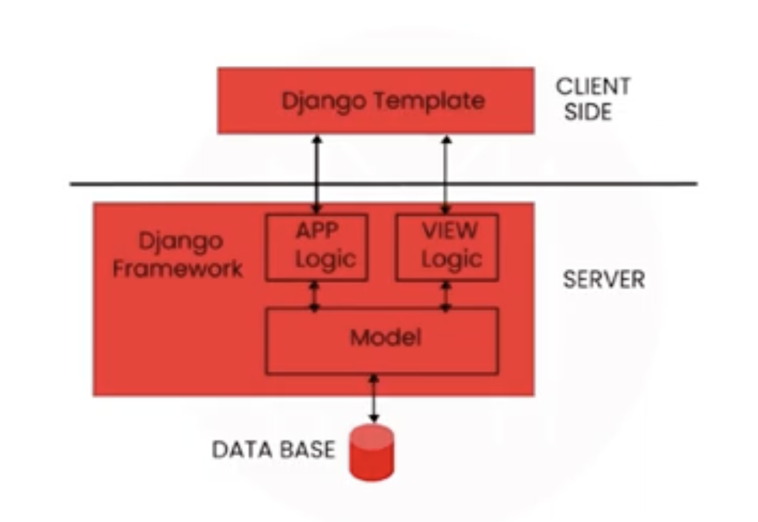

From the above diagram You can see the template is on the client side which is basically HTML CSS. Both the model and view are on the server side. So django uses request and response objects to communicate between the client and the server. So if the website receives the request it is transmitted from the browser to the server to manage the view file using a template. After sending the correct url request the app logic and model initiate the right response to the presented request so after that the detailed response is sent back to you to check the response and transmit it as an http response or the desired user format. So then again it passes to the browser via the templates.

**Basic Files:**

You'll typically find these three types of files in a Django project:

* Source code: These are your core Python modules and HTML files that make up every Django project, where you define your models, views, and templates.
* Static files: These are your CSS stylesheets, JavaScript files, fonts, and images. Since there's no processing involved, these files are very energy efficient since they can just be served up as is. They are also much easier to cache.
* Media file: These are files that a user uploads.

**Features:**

-Compared to other open source technologies, django offers excellent documentation in the market so it is the only framework which is helpful in solving any problem associated with the app development.

-Django is SEO (**Search Engine Optimization**)optimized, scalable and can flexibly switch from small to large scale projects

-Versatile in nature: it allows you to develop applications for various types of domains. It has vast community to connect with and share

-Rapid development

Reusability:One of the advantages of the Django app is reusability. Django is a combination of applications so copying those apps from one directory to another with some tweaks of the setting.py file won't need much time to write new applications from scratch. So because of this Django is the rapid development framework and this kind of code reusability is not allowed in any other frameworks.

**Advantages:**

* Compatible with major operating systems and databases.
* Supports MVC paradigm
* Provides better CDN(content delivery network) connectivity and content management
* Designed as batteries included framework
* Provides JSON field support for all the database backends
* Admin layout
* Path libraries
* Code Reusability

Reference :

*Department of Disability and Aging Services (DAS) disability in San Francisco*. Disability in San Francisco | San Francisco Human Services Agency. (n.d.). Retrieved December 10, 2022, from https://www.sfhsa.org/about/reports-publications/disability-san-francisco

*Department of Disability and Aging Services Older Adults in San Francisco*. Older Adults in San Francisco | San Francisco Human Services Agency. (n.d.). Retrieved December 10, 2022, from https://www.sfhsa.org/about/reports-publications/older-adults-san-francisco#:~:text=Growing%20Population&text=Nearly%2030%25%20of%20San%20Francisco,2020%3A%2023%25

*Household types in San Francisco, California (city)*. The Demographic Statistical Atlas of the United States - Statistical Atlas. (n.d.). Retrieved December 10, 2022, from https://statisticalatlas.com/place/California/San-Francisco/Household-Types

*Platform delivery - worldwide: Statista market forecast*. Statista. (n.d.). Retrieved December 10, 2022, from <https://www.statista.com/outlook/dmo/eservices/online-food-delivery/platform-to-consumer-delivery/united-states>

<https://www.youtube.com/watch?v=lCCN_lkl3Xw&t=31s>

<https://nullphp.net/assets/posdash-html-admin-template/>

<https://docs.djangoproject.com/en/4.1/ref/request-response/>

[www.codewithmosh.com](http://www.codewithmosh.com)